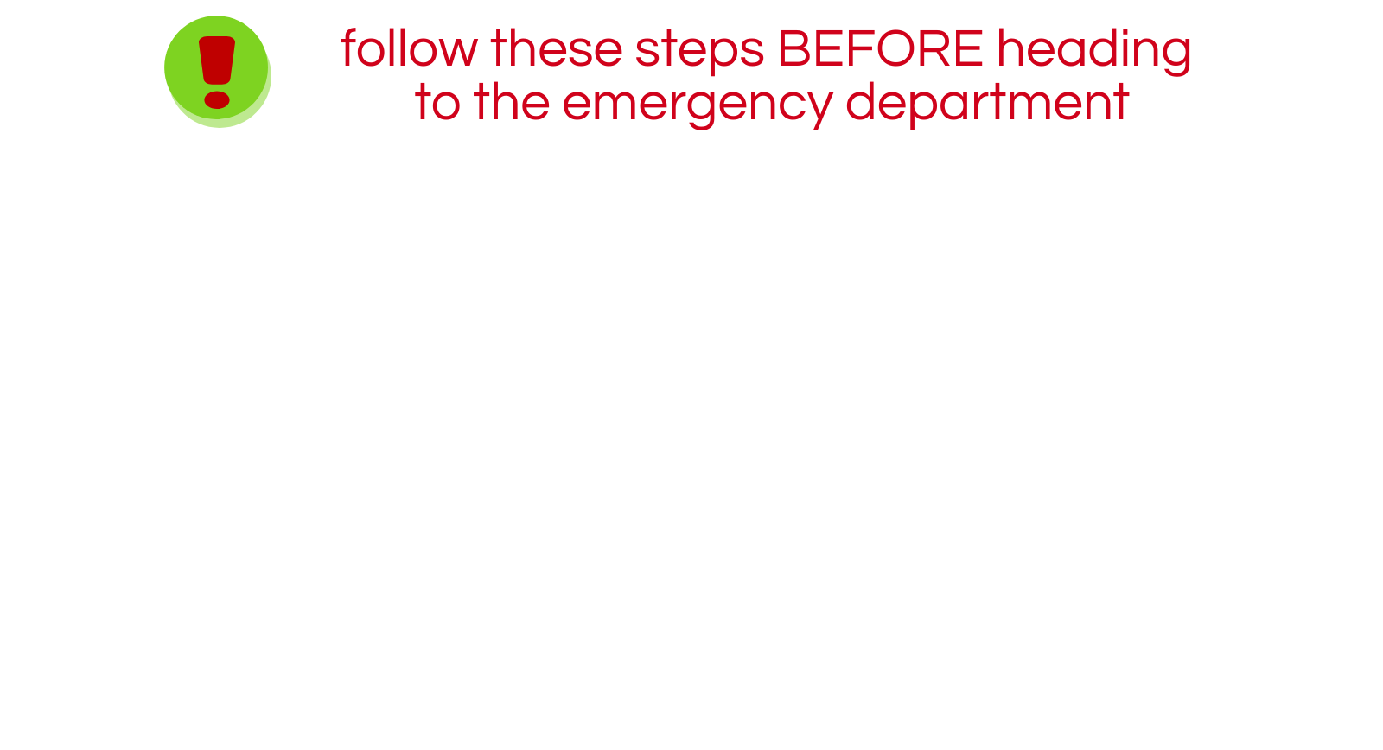**CALL OUR OFFICE: 250-999-9999**

Use this section to identify processes within your office. For example:

WE WILL BE CLOSED ON DECEMBER 24, 25 & 26.

If you need an urgent prescription refill, please call your pharmacy. They may be able to provide you with an emergency supply.

The Urgent Primary Care Centre located at 311 Columbia St. accepts bookings from 5:00pm – 8:30pm. Call 250-314-2256.

You can adjust font size to make your text fit the space.

**Monday:**

**Tuesday:**

**Wednesday:**

**Thursday:**

**Friday:**

**Weekends:**

**8:00am – 8:00pm Closed for lunch 12:00pm – 1:00pm**

**8:00am – 8:00pm Closed for lunch 12:00pm – 1:00pm**

**8:00am – 8:00pm Closed for lunch 12:00pm – 1:00pm**

**8:00am – 8:00pm Closed for lunch 12:00pm – 1:00pm**

**8:00am – 8:00pm Closed for lunch 12:00pm – 1:00pm**

**8:00am – 8:00pm Closed for lunch 12:00pm – 1:00pm**