Coordinating Complex Care for Older Adults
Evaluation Report

March 2023
Surrey North Delta
Division of Family Practice

Prepared by Reichert and Associates
201 – 1847 W Broadway
Vancouver, BC V6J 1Y6
T: 604-428-2478

Table of Contents
Table of Contents 1
Acronyms and Abbreviations 1
Introduction 3
About the Project 3
Goals of the Project 3
About the Evaluation 3
Evaluation Approach 3
Methods 3
Limitations 4
Evaluation Findings | Organization and Operation 5
Evaluation Findings | Home Health 5
Activities & Outcomes 5
Sustainability 9
Evaluation Findings | Specialized Seniors Clinic at Jim Pattison Outpatient Clinic (JPOC) 9
Activities & Outcomes 9
Sustainability 11
Evaluation Findings | Lessons Learned 11
What worked well? 11
What were the challenges? 12
Summary – Overall Project Outcomes 12
Recommendations & Next Steps 13
Home Health 13
Specialized Seniors Clinic a JPOC 13

Acronyms and Abbreviations
FP | Family Physician
CCCOA | Coordinating Complex Care for Older Adults
JPOC | Jim Pattison Outpatient Clinic
SNDDFP | Surrey North Delta Division of Family Practice

Introduction
This is the final evaluation report of the Surrey North Delta Division of Family Practice (SNDDFP) “Coordinating Complex Care for Older Adults” (CCCOA) Project which operated between June 2020 and March 2023. This project aimed to support coordinated care of older adults with co-morbidities, so they can remain at home and be healthy as long as they are able.

About the Project
Project documents highlighted two gaps in care: 1) 2) a need for early intervention and assessments to delay frailty and support seniors at home longer.

Goals of the Project
This project had two components. One was done in collaboration with Home Health and the other with the Specialized Seniors Clinic. As per project documentation the CCCOA project set out to achieve the following in both components of the project:
- Improve communication and collaboration as a multi-disciplinary care team as seniors transition through various providers and parts of health system.
- Support seniors to stay at home as long as possible by connecting with home health and community supports.

About the Evaluation

Evaluation Approach
The evaluation is intended to provide feedback on the implementation, operation, and potential outcomes of the project. The evaluation was designed to be participatory and developmental. The following questions guided the evaluation:
Process Questions | - To what extent was the project implemented as planned?  - To what extent was the project able to identify and engage the necessary stakeholders?
Outcome Questions | - To what extent did the project achieve its planned results?  - What lessons does the project provide that could be used to improve patient care and efficiencies in other populations or locations?  - To what extent are the outputs/outcomes sustainable?

Methods
The evaluation included the following data collection methods:
Document/ Admin Data Review. The evaluation team reviewed relevant project documentation including the project planning documents (i.e., funding proposal, meeting minutes etc.) and project administrative data (i.e., event attendance).
Key Stakeholder Interviews. In addition, a total of 8 semi-structured telephone interviews were conducted with working group members, including FPs, and representation from both Home Health and the Specialized Seniors Clinic. These interviews gathered information on what was implemented, project team challenges and successes, overall project impacts, project sustainability and next steps.
Surveys. Post-event surveys were administered following meet and greet sessions hosted by the project (Table 1) to assess attendees’ perspectives on whether the session and learning objectives were met. Post-event surveys provided the evaluation with timely qualitative and quantitative information from a variety of perspectives.
Table 1. Overview of learning and engagement sessions hosted as part of the CCCOA Shared Care Project
Event | Date | # post-event survey responses
Meet and Greets – Cohort #1. Aimed to improve communication between CHNs + FPs, FP familiarity of their CHN, FP understanding of the CHN role and FP understanding on how to refer to Home Health. | March 2021 | 9 FPs (response rate: 9/19 attendees; 47%)
Meet and Greet – Cohort #2. Aimed to improve communication between CHNs + FPs, FP familiarity of their CHN, FP understanding of the CHN role and FP understanding on how to refer to Home Health, communication between CHNs | March 2022 | 22 (response rate: 22/31 attendees; 71%)
CME Event – Wound Care for FPs  CME event for local family physicians to learn more about wound care | February 2023 | 40 family physicians (response rate: 100%)

In addition, surveys were sent out to FPs at two different time points during project implementation to determine if they received the newly implemented Home Health cover sheet and patient list, and whether the cover sheet was useful to them. (Table 2)

Table 2. Overview of Home Health cover sheet and patient list evaluation survey distribution and responses
Date | # survey responses
December 2021 | 43 (response rate: 24%)
July – August 2022 | 68 (response rate: 28%)

Contextual Analysis: All evaluation information was analysed within the context of the program’s stated goals and objectives.

Limitations
A potential limitation associated with using semi-structured interviews is participants not being able to recall all experiences. In order to mitigate this, participants were sent the interview guides in advance of their interview date, allowing them time to review questions and reflect on their experiences. By doing this, it was less likely that participants were caught off guard or surprised by any questions that were asked within the interview itself.

Evaluation Findings | Organization and Operation
The CCCOA project received direction from a working group, with members including local family physicians, Fraser Health representatives (Home Health, Specialized Seniors Clinic) and a Surrey North Delta Division of Family Practice Project Manager.

Evaluation Findings | Home Health
The following section summarizes the activities and outcomes of the activities associated with the Home Health component of the project.

Activities & Outcomes
- Meet and Greet Events
About

Meet and greet events were hosted with FPs and home health nurses with the intent of:
- Improving communication between Home Health CHN and FPs.
- Improving FPs knowledge of who their CHN is.
- Improving FPs understanding of the CHNs role.
- Improving FPs understanding on how to refer to Home Health.
- Improving FP and CHNs understanding on the bets ways to communicate with one another and how often to communicate with one another.
Two meet and greet sessions were hosted, one in March 2021 and the second in March 2022. 19 FPs and 3 CHNs attended the March 2021 sessions and 31 FPs and 12 CHNs attended the March 2022 session.

Impacts & Outcomes

Interviewees indicated that providing opportunities for FPs and CHNs to meet was an important part of improving their familiarity and understanding of one another.

“Working with home health has been super helpful. That home health communication barrier, overcoming that has been really helpful. So, that was one of the main accomplishments.” – Working group member

90% of FPs who attended one of the two meet & greet sessions agreed that they knew who their CHN was 6-months after the session, as compared to only 42% before the session (Figure 1). Similarly, a greater proportion of FPs also agreed that they knew what the role of the CHN is, following the session (Figure 2).

Meet and greet sessions also supported improved communication or potential for communication between FPs and CHNs. For example, nearly all (97%) of attendees indicated that they know how to refer to Home Health following the session (Figure 3). In addition, 90% of attendees also indicated that they and how to contact their CHN following the meet and greet session that they attended, as compared to only 32% indicating that they knew how to do this prior to the session (Figure 4).

- Home Health CHN fax cover sheet and list of patients
About

A cover sheet was designed to help remind FPs who their CHN is and which patients are currently being seen by Home Health. It included information about the CHN such as their name, their contact information and their Home Health office location. This information is sent to FPs quarterly by Home Health.
Impacts & Outcomes
Interviewees indicated that the development and use of the CHN cover sheet and list of patients helped FPs and CHNs become more familiar with one another, and created opportunities for connection regarding patient care. One interviewee indicated that the project increased CHNs comfort in communicating with FPs, ultimately improving overall patient care planning and timeliness.

“I knew yesterday that the [CHN] was calling. That's going to be something that happening with the two people that [they] want to talk to me about, so, we respond to as quickly as we could” – Working group member | “FPs are able to know which of their patients are actually assigned to Home Health or are receiving Home Health services….we've heard that it triggers the FP to go through [the list]…it can trigger a phone call to a CHN. So we've heard that that is happening more often.” – Working Group Member

During project implementation, approximately two thirds of FPs consistently reported that they remember receiving the cover letter and patient list (Figure 5.).

Finally, 87% (27 of 31) of FPs agreed that they were happy with the frequency of communication about their Home Heath patients between themselves and their CHN.

- Wound Care CME Event
About

A CME event was hosted with the intent of helping FPs learn more about wound care. It was hosted in February 2023, with 40 FPs in attendance.

Participant Satisfaction

All attendees of the CME Wound Care event ‘strongly agreed’ or ‘agreed’ that they enjoyed the format of the presentation. (Figure 6).
“Appreciated the discussion of different types of wound care products for moisture balance!”
“We always refer to complex wound clinic and it was nice to see [doctors] virtually in person.”
- Event Attendees

Impacts & Outcomes

65% of FPs who attended the Wound Care Event indicated that they had a chance to learn who their CHN was and 15% indicated that they already knew who their CHN was. (Figure 7)

Attendees of the Wound Care CME event agreed that they have gained a better understanding of the basic anatomy of healing wound, of the 4 phases of wound healing, and they understand the difference between acute wounds and chronic wounds, among other learning goals (Figure 8).

Sustainability
Working group interviewees indicated that they were confident in the sustainability of the changes and progress made between Home Health and FPs. The following plans have been made to enable sustainability of the processes and gains made by the project:
- Home Health (Fraser Health) has standardised the cover letter and patient list which is now sent out to family physicians quarterly and has indicated that this included in the training of new CHNs. Working group members noted that continued reinforcement of the value of this process should come from Home Health leadership.
- Maintaining FP partnerships is discussed at Home Health monthly quality committee meetings.
- Future concerns or challenges between Home Health and FPs will be directed to the Primary Care Networks, as these are a place of collaboration between the health authority and community providers.
“That kind of ownership is really important. Just have somebody be the champion and lead to do the work and connect back to the home health team because obviously I can't have all the managers and team leaders involved. They have too much work in other areas. Having that dedicated support would be important.” – Working Group Member

Evaluation Findings | Specialized Seniors Clinic at Jim Pattison Outpatient Clinic (JPOC)
The following section outlines the activities and outcomes of the work with the Specialized Seniors Clinic at JPOC.

Activities & Outcomes
- Communication process mapping, gap analysis, and change recommendations
About

The project team conducted workflow mapping sessions to assess the patient journey, starting with the FP’s patient referral to the Specialized Seniors Clinic through to the point of discharge from the clinic. From that, they were able to identify potential ways to improve communication between the Seniors Clinic and FPs. They then proposed change recommendations to the Seniors Clinic which included the following:

The revision of a complex care round toolkit to be used to improve communication and collaboration between the interdisciplinary team at the Seniors Clinic and the patient’s FP. The toolkit is currently being trialled and therefore future evaluation is needed to assess its impacts.
The creation of a data dashboard to allow the Seniors Clinic to access statistics such as wait times to Seniors Clinic access and patient length of stay at the clinic. This information could help identify existing gaps in connection between FPs and the Seniors Clinic and inform future work. Fraser Health has pulled this data and shared the summary on March 23, 2023.

Images from the data dashboard can be found below. Some highlights relevant to primary care included:
- 90% of referrals came from community-based physicians
- Average wait times from referral to initial appointment declined, while wait times from waitlist time to initial appointment were stable
- Average length of stay (LOS) declined ~50%
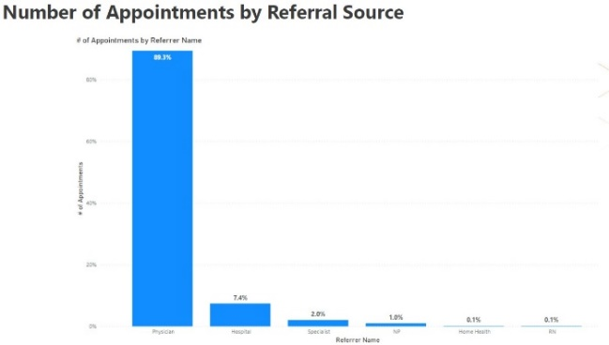
- Share of unattached patients decreased 50%, from 4% unattached to 2% of patients
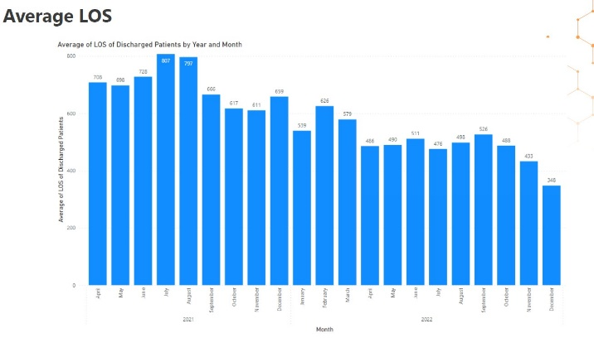

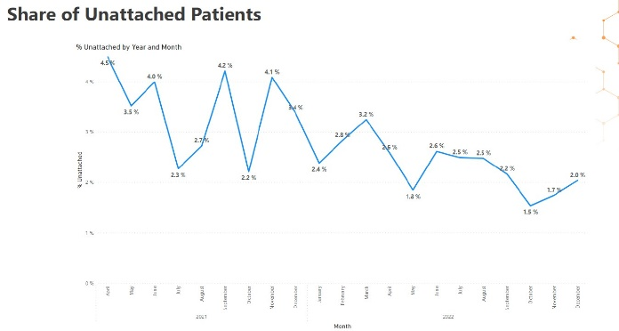
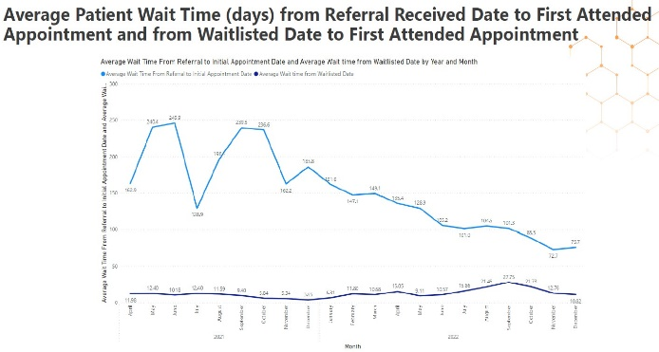

Additional administrative data collected via the data dashboard can be found within the “Performance Metrics for Seniors Specialized Clinic (SSC), Surrey North Delta Divisions of Family Practice” presentation which will be submitted as an accompanying document with this report.
Impacts & Outcomes

Interviews indicated that the project and associated project activities “opened the door” for more communication between FPs and the Seniors Clinic. A member of the working group indicted that the Specialized Seniors Clinic was better able to understand the gaps that existed for FPs as a result of the project.

“…understanding where some of the gaps were from the division perspective was definitely a part of that and I think was something that was hit in the work”. – Working group member

One interviewee also highlighted that project team meetings attended by both groups provided dedicated time for the two groups to connect in real time allowing them to listen and learn from another as well problem solve around existing challenges. | “Great to problem solve and putting our heads together, in real time, not just faxing or sending emails or phone calls. It was nice to see both sides invested.”  “I think it creates less anxiety knowing that on the other end, the door is open, and they are receptive, and they are interested…It’s a nice feeling to know that there’s an avenue and who to go to.”  – Working Group Members

- Revised referral form & referral acknowledgement process
About

The referral form used by FPs to refer patients to the Specialized Seniors Clinic was revised by the project team to improve consistency of information received by the clinic. In addition, the project team suggested a process to send referral acknowledgement back to FPs from the Seniors Clinic.

Impacts & Outcomes

A member of the working group indicated that prior to the project, the referral acknowledgement letter was being uploaded onto Meditech by Seniors Clinic staff. However, not all FPs have access to Meditech, and therefore the referral acknowledgement was not being communicated. As a result of the project, there has not been a linkage created between the systems used by the clinic and by FPs.

“Improved communication between FPs and the clinic themselves, so that was just creating a bit of communication channel…That was an eye opener because at the time Seniors clinic didn’t realize that’s how FPs were getting it. They were just uploading it onto Meditech and they thought every FP had access to Meditech and they don’t. So we didn’t have to do anything differently other than create that linkage between UCI and whatever the other one was. Those kinds of things.” – Working Group Member

Generally, interviewees agreed that there is longer term evaluation is needed to assess FP and Seniors Clinic satisfaction with changes made to the referral form and communication channels between the two groups, as a result of the project, as well as to assess the overall outcome and impacts of this work.

Sustainability
Working group interviewees highlighted the importance of a strong champion in sustaining the work that has been done. They noted that continued reinforcement of the value of this process should come from Specialized Seniors Clinic leadership.
“The toolkit, I would say everything is sustainable if its being used. They need a champion…It’s got the potential to be sustainable in the long term and have some significant patient outcomes but what it needs is someone who is able to champion it.” – Working group member |  | “The data dashboard is sustainable providing it is operational, so once its operational, the seniors clinic, its at their discretion how often they want to use it and how often they want to use the information.” – Working group member

Evaluation Findings | Lessons Learned

What worked well?
Members of the working group indicated that team member and stakeholder buy-in and dedication was as a primary facilitator to project success and progress. Several interviewees noted the value of buy-in and championing of the project by leadership on all sides (FP Leads, Home Health, and Seniors Clinic). One interviewee indicated that everyone’s willingness to have open and transparent discussions was beneficial to project success.

“We had excellent stakeholder involvement…from the beginning ... [they] came with the spirit of collaboration.…’yes let me look into that’ ‘yes, I hear what you’re saying’ ‘what can we do about that’ ‘here are the challenges that we face’, ‘what are your suggestions?’’ – Working group member |  | “[FP leaders] were strong advocators … they were invested in the project not just because of the project itself but because of its implication on a larger scale. So that was valuable.” – Working group member

Interviewees indicated other facilitators of project progress and success which included the following:
- Having consistent and regular monthly team meetings, communication, and collaboration on project progress
- Having high attendance at monthly team meetings as well as shared accountability of project success
- Consistency (low turnover) of team members (particularly of leadership) throughout the project
- Strong project management and coordination support (i.e., sending reminders, preparing agendas, etc.)

“Having the meeting at a set time and in a set day of the month. It was reserved, so you knew that that time is specifically for that, and everybody respected that, and would acknowledge if they weren’t able to make it…we would find a suitable time so that everyone could be there…everybody was accountable to coming to the table for this and being invested is what made it successful.” – Working Group Member |  |  | “I think really it all came around to the two things: communication and connection. That was what kind of kept thing moving and successful.”– Working Group Member
“We had consistent stakeholder involvement and the championing of the project almost all the way along.” – Working Group Member

What were the challenges?
Interviewees noted some challenges related to project progress and success around work done in collaboration with Home Health and the Seniors Clinic. Several interviewees highlighted how high workloads and staffing shortages within the Seniors Clinic hindered their team’s ability to trial some of the project activities within the timeframe of the project.
“We had short staffing issues, so we couldn’t pilot the things that we were hoping to just with added tasks, it wasn’t feasible at that time.” – Working group member |  | “It’s the workload on our staff…we have such a turnover and we had injuries. It was just that we had no one... Couldn’t add one more thing to their plate. So, we are unable to implement. But our plan is... I think we are planning March. We should be all back and kind of caught up. And their plan is to implement it.” – Working group member

In addition, because the referral form used between the Specialized Seniors Clinic and FPs is owned by Fraser Health, the project was not in a position to make changes directly to it.
And lastly, one interviewee noted that some meet and greets set up to facilitate connection between FPs and Home Health had lower attendance from the FP side.
“For example… meet and greet with the GPs, some sessions are great... whereas other sessions, the attendance for GPs is low. … [they] need ongoing prompting and encouragement …It’s agreed by the GP that it’s useful although they couldn’t attend.” – Working group member

Summary – Overall Project Outcomes
Evaluation findings suggest that the CCCOA Shared Care project helped improve communication and collaboration between care teams to help seniors transition through various providers and pats of the health care system. Communication and connection between FPs and Home Health, particularly Home Health CHNs, has become more a more routine part of practice both FP and CHN practice. From Home Health’s side, connecting with FPs has become a standardized part of CHN responsibility. While there is still more work to be done to improve communication and collaboration between FPs and the Seniors Clinic, the CCCOA project has laid a solid foundation from which this work can continue to grow after project end.

While evaluation findings did not specifically outline that the project supported seniors in staying home as long as possible, it is important to note that this may be a more longer-term outcome influenced by a multitude of factors. The CCCOA project and the progress made through it may be a contributor to this goal in the future.

Recommendations & Next Steps

Home Health
While working group members were satisfied with the changes and progress made between Home Health and FPs, some interviewees indicated that to sustain these changes and progress, there would need to be ongoing two-way communication and relationship building occurring between Home Health and FPs in order to continually assess and address gaps, as well as include FPs that are new in the community.

“…ongoing planning priority with the Division… it’s not just what the Home Health would do but there’s a piece of work that [the project managers] done to facilitate the GPs’ participation as well as kind of some proactive planning… knowing what’s needed… that sort of feedback to know where the gaps are… without that information it’s hard for us to address the gaps if there are any…I think that ongoing relationship is really important.” - Working group member

Specialized Seniors Clinic at JPOC
Upon completion of the complex care round toolkit trial and the approval of the data dashboard by Fraser Health, it is recommended that the Seniors Clinic evaluate the impacts of these resources and assess how they do or do not address the intended goals. A working group member also highlighted how the data collected through the data dashboard could help assess current aspects of the Seniors Clinic such as wait times and patient length of stay at the clinic, and from that appropriate next steps could be determined. This interviewee also highlighted the value of involving hospitalists in problem-solving moving forward to optimize communication and referrals between the Seniors Clinic, the hospital, and FPs. Generally, working group interviewees indicated that it would be important to continue optimizing communication between FPs and the Seniors Clinic.
Conclusion
The CCCOA project was successful in bringing together stakeholders to address gaps in care for seniors in Surrey-North Delta. Key successes were in increasing FP awareness of the CHN role and building relationships with Home Health, increasing knowledge and confidence of family physicians, and increasing access to data for informed decision making. The project has created a foundation of collaboration between FPs and Home Health and the Specialised Seniors Clinic that can continue to benefit providers and patients in Surrey North Delta into the future.

