Hi All,

As many of you have heard, RCCbc has been working toward a 24/7 live with video support for rural physicians called RUDi, this has been ongoing since last fall. This service will initially connect you with EM support, as it evolves we hope to add other pathways for support such as dermatology, mental health, etc. The platform this service will use is Zoom to address our physician’s request of one tool ideally for everything. Many of you have your RCCbc Zoom accounts by now, for those of you who do not you can sign up at: <https://rccbc.ca/zoom/>

Once you have your Zoom account, it’s recommended you install the Zoom client as long as you work on a computer that allows you to install your own software. Log into the Zoom client, then click on the “Contacts” button as show below:

cid:image001.png@01D6066F.340E7EB0

This will open a panel on the left of the Zoom client. In the section “Company Directory” section, you’ll see several groups. Click on the little arrow to the left of the “RUDi Support” option to expand the group:

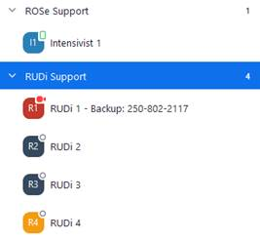

Click on the “Rudi 1” icon cid:image003.jpg@01D60835.30199480, this will populate the right panel in the Zoom client with options to contact EM support, select “Meet” to place a live Zoom call:

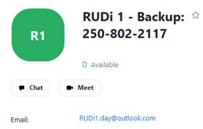

**Note\*** If the Zoom call does not go through, please use the cell number listed in the contact display to reach EM support as a backup.

In the “Company Directory” section, you’ll also see a “ROSe Support” group:



This support pathway will connect you to an Intensivist 24/7 for live video based support. Select “Meet” to place a live Zoom call to an Intensivist:

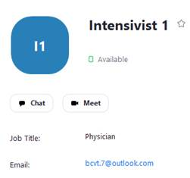

If you want to use Zoom on your iPad or smart phone, you can tap on the “Contacts” option to access the same RUDi/ROSe Support contact list as outlined above.

Availability is displayed as:

**o** means offline​  
**[]** means available (mobile)​  
**o** means available (computer)​  
cid:image007.png@01D60835.30199480   means on video call​  
  
Video walkthrough for practitioners seeking support through RUDi: <https://youtu.be/OcjDjjPkiKw>  
  
This service is live now, please use it as needed.

NOTE* **If your Zoom account was provided by your health authority or you signed up for your own, outside of RCCbc, you will need to add the RUDI contacts to your account.**

1. Log in to the Zoom app on your phone or the desktop client
2. Click on Contacts to see your contact list
3. Click the ‘+’ icon and “Add a contact”
4. Add [rudi1@rccbc.ca](mailto:rudi1@rccbc.ca) to your contacts
5. Repeat with [rudi2@rccbc.ca](mailto:rudi2@rccbc.ca), [rudi3@rccbc.ca](mailto:rudi3@rccbc.ca), [rudi4@rccbc.ca](mailto:rudi4@rccbc.ca)
6. Contact may be ‘pending’ for up to 24 hours

[Video walkthrough](https://youtu.be/agE4EaR4dNM) of this process in the Zoom phone app.