Emergency Management Workbook for Divisions of Family Practice

Division name: Northern Interior Rural Division of Family Practice

Division address: PO Box 114, Prince George, BC, V2L 4R9

Date completed: Third draft March, 2023

Signed:

Contents
Introduction 3
Plan Objectives 4
Community Based Emergency Response 4
NIRD Capacity 4
NIRD EOC Participation 4
Contact Information 5
Facility Emergency Preparedness Planning 6
Northern Health Emergency Plans 7
Site-Specific Emergency Management Plan 7
Document Review 9

Introduction

The Northern Interior Rural Division of Family Practice (NIRD) is spread out over an expansive geographical area, from Quesnel in the south, Mackenzie in the north, Valemount to the east and Burns Lake to the west. This area covers approximately 144,000 km² and over 1000km.

There are nine staff personnel that support over 100 healthcare provider members from the eight non-Indigenous communities and 22 Indigenous communities of which NIRD is comprised. All NIRD staff work remotely and do not operate out of one fixed office building. Four of the NIRD communities have administrative staff personnel present in those communities. However, the organization does have a Representative Assembly and/or Board membership in the eight non-Indigenous communities and a floating Indigenous membership that represents the Indigenous communities.

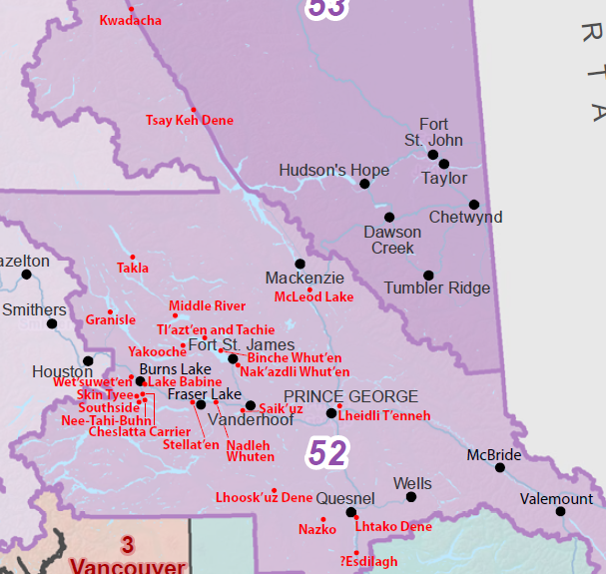
Figure 1: Northern Interior Rural Division of Family Practice geographic range and community list.

The NIRD Representative Assembly is a table comprised of physicians from across the NIRD operating area. There is one Chair plus 1-2 physician representatives from each of the non-Indigenous communities, and one physician representative for the Indigenous communities. These physicians are the communication links between the physician members and the NIRD staff and Board of Directors. NIRD’s Board of Directors are comprised of three physicians, and three specialized community members. The organization also boasts a Physician Leadership Table which generally operates as a working group of the R/A vetting new members, policy and general member feedback.

Plan Objectives

The objectives of this Emergency Preparedness Plan document are twofold:
- To outline how NIRD can support an emergency within any one of its member communities. Note: This is the a Community Based Emergency Response.
- To compile and distribute a list of available resources NIRD can use to support managers of health facilities within the NIRD region to ensure their facility has the appropriate emergency preparedness plans in place in the event of an emergency. This is in conjunction with the Facility Emergency Preparedness Planning and the community’s Local Emergency Plan.

Community Based Emergency Response

NIRD Capacity

NIRD personnel staff have limited capacity to actively engage and participate in an EOC, simply due to the nature of the organization with remote workers living across the province. How NIRD can participate in an emergency situation in one of its member communities is through:
- Participation in the Northern Interior Rural Collaborative Services Committee (CSC). The CSC is comprised of representatives from NIRD, Northern health – Clinical Operations and Public Health, First Nations Health Authority, Family Practices Services Committee and Carrier Sekani Family Services. The CSC would be a realistic forum where NIRD can actively participate and support any directives to support member communities in the case of an emergency.
- Participation in any Local Health Planning Tables (if applicable) in the impacted community. For example, in Vanderhoof during the COVID-19 response, the Omineca Regional Response group was formed that was the community based communication link between the health care facilities and the community. As directed by the NIRD Executive Director, NIRD staff could engage in these tables to support communication to member providers.
- Providing an emergency planning template to member providers so they can themselves prepare their clinics for emergencies that could impact their sites.

NIRD EOC Participation

If directed or invited to participate in an EOC that is activated by either Health Emergency Management BC (HEMBC), or Emergency Management BC (EMBC), NIRD would respond with the NIRD Executive Director/Operations Manager, the Representative Assembly Chair, and the impacted community’s physician Representative as the lead lead team to support the response.
NIRD TEAM LIST
The NIRD staff list and Representative Assembly members are listed here:

Table 1: Roles and responsibilities of NIRD team to support an ICC.
ROLE | Division Representative(s) | Key Responsibilities | Communicates with:
Communications and logistics | NIRD Executive Director/Operations Manager | Connect with HEMBC and or EMBC Incident Commander to establish role in response. If support role is required:  - Support impacted community/members as may be required.  - Communicate to NIRD members as appropriate.  - As needed, assign staff or NIRD executive members to support logistical and communication tasks as appropriate or, as recommended by the ICC Incident Commander. | HEMBC/EMBC Incident Commander, Representative Assembly Chair, Community Member Representative(s)
Additional role | Representative Assembly Chair | Ensure community Representative is being supported by NIRD. Delegate any actions to the Representative Assembly member(s) as needed to support impacted community and its members. | NIRD Executive Director
Additional role | Representative Assembly Physician member(s) for impacted community(s) | Provide information up to the team to inform on the situation in community. | NIRD Executive Director
additional role | NIRD Staff as needed | Support Executive Director in Communications and Logistics as necessary. Connect with any Local Health Planning Tables in the impact community. | NIRD Executive Director

Contact Information

This is a living document, therefore we recommend going to the NIRD website for current contact information.
NIRD Executive Director: Errol Winter, ewinter@nirdbc.ca, 1-778-281-2887
NIRD Executive Secretary: Jodi Bennett, jbennett@nirdbc.ca, 1-250-612-2040

Facility Emergency Preparedness Planning

Within the eight non-Indigenous and 22 Indigenous communities that NIRD serves, there are 20 primary care facilities, including Northern Health operated and funded hospitals and clinics, as well as physician operated private clinics.

Table 2: NIRD supported community and facility summary.
Non-Indigenous Community | Indigenous Community Partner | No. Physician Members | No. Northern Health Facilities | No. Private Health Facilities
Burns Lake | Lake Babine Nation serving the communities of Woyenne, Tachet, Fort Babine, Donald’s Landing, Old Fort (Nedo’ats) | 17 | 3 | 1
 | Nee-Tahi-Buhn
 | Skin Tyee
 | Tsil Kaz Koh (Burns Lake Band)
Wet’suwet’en
Granisle
Southside
Fraser Lake | Nadleh Whut’en | 8 | 1 | 0
 | Stellat’en
Vanderhoof | Saik’uz | 13 | 1 | 1
Fort St. James | Nakazdli | 7 | 2 | 0
 | Tl’azt’en (Tache, Middle River – Dzitl’lainli, K’uzche
 | Binche
 | Takla Lake
Mackenzie | Kwadacha | 10 | 1 | 0
 | McLeod Lake
 | Tsay Keh Dene
Quesnel | ?Esdilagh | 28 | 3 | 5
 | Lhoosk’uz Dene
 | Lhtako Dene
 | Nazko
McBride |  | 5 | 1 | 0
Valemount |  | 8 | 1 | 0

Each facility within the NIRD region should have emergency preparedness plans in place. These can be Northern Health template plans (eg. Code Green), and/or site-specific Emergency Management Plans. These plans are important documents for individual facilities to ensure they have appropriate plans in place to address a range of disaster and emergency situations that could impact staff, patients, and/or the facility.

Northern Health Emergency Plans

All Northern Health operated/funded facilities have access to their specific policy and procedure emergency documents via the Northern Health Emergency Management (North) online portal. These documents include:
- Site specific Code Orange and Code Green documents
- Emergencies and Disaster Staff Self-Care document

These emergency plans follow a Northern Health template but are intended to be modified to address local conditions, contacts. The plans should be reviewed and updated on a regular basis by local teams. NIRD staff and physician Representatives are encouraged to check-in and ensure their facility has current plans in place.

Use this section to keep track of any NH plans used by NIRD staff.

NH Emergency Documents
Document Last Updated

Site-Specific Emergency Management Plan

Additional to the NH provided emergency documents, each facility – NH run or physician run clinic - should prepare their own site-specific Emergency Management Plan. A guidebook and workbook are available for facility administrator to complete for their facility.

NIRD staff, through the direction of the Executive Director, will distribute these templates to health facilities in their region and encourage the facilities to complete the plan. Facilities should report back to NIRD when completed.

Access the plan documents: [will have NIRD versions for your website as a download, but for now linking to]
- Guidebook
- Plan Workbook

Use this section to keep track of which health facilities have completed Emergency Management Plans.

Facility Site Specific Emergency Management Plan in place (date and contact)

Document Review

It is recommended that this document be reviewed on an annual basis to update and revise as needed.

This plan - Last Updated

The Emergency Management Plan guidebook and workbook should be reviewed on a ______ basis to ensure it is current and relevant based on direction from Health Emergency Management BC.

EMP documents - Last Updated

