Wolf: How to Pull a Patient List and Export into Excel Spreadsheet and Import into MailChimp
- In Practice Search under Demographics, you will need to add “Primary MD”. Run report.
Screen shot below:
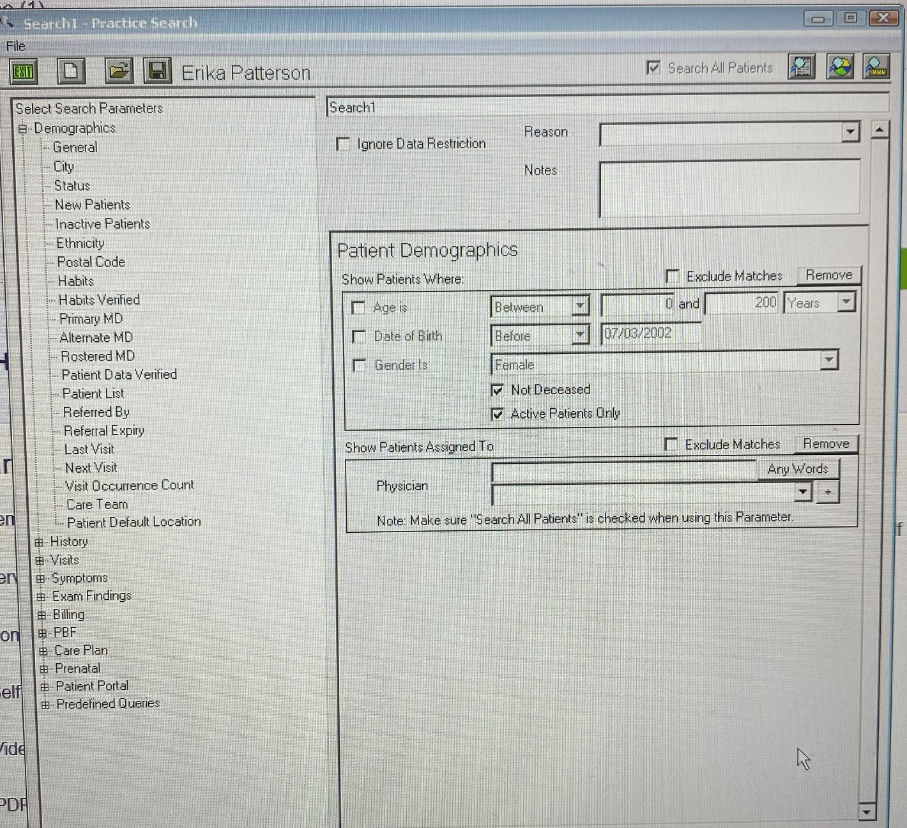

- Once you have run your report you a list of patient names will pop up. Go to “File” and choose “Export All to CSV”. This is going to pull your report up and you can save it to the Wolf Desktop.
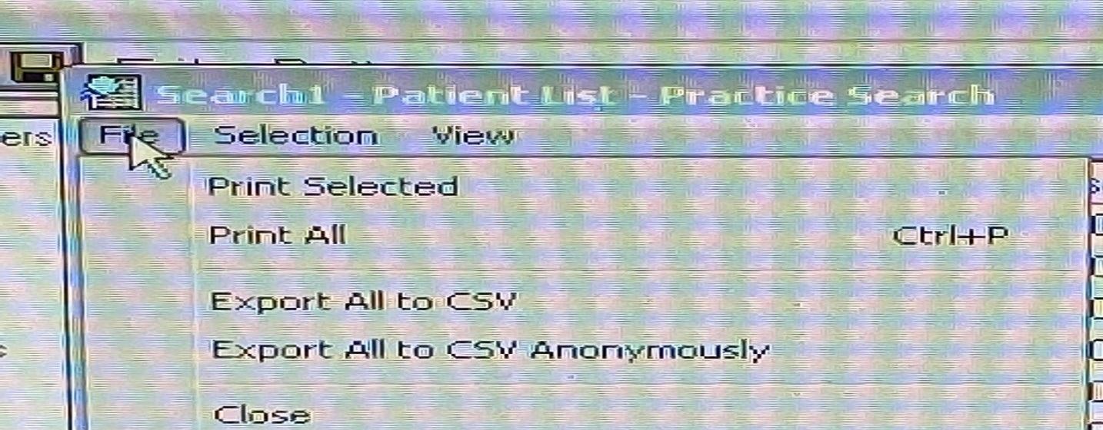
- From the Wolf Desktop, right click on the saved spreadsheet and “Open in LibreOffice Calc”. This will open a spreadsheet. You can begin editing your spreadsheet by deleting those columns you do not require. Simply, highlight a column by clicking on the top (ie Column C = DOB). Right click on the mouse and click on “delete column”. You can remove all columns that you do not require.
In the Excel spreadsheet all you will need are: First Name, Last Name and Email Address.
Once you have edited this, you will need to copy this data and paste it into an Excel Spreadsheet.
When you are satisfied with the edited version of this spreadsheet then you can save it as a CSV file. See screen shot below which shows what to look for when saving a CSV file. (there are a few to choose from)
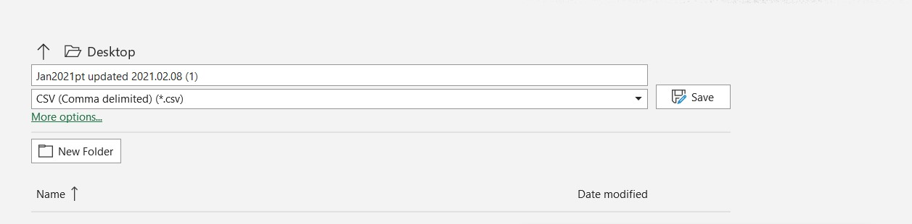
- From here you would open your MailChimp account. Click on “audience” which is on the left-hand side of the page. Click on “Manage Audience”, which is on the right-hand side of the page. Click on “Import Contacts”.
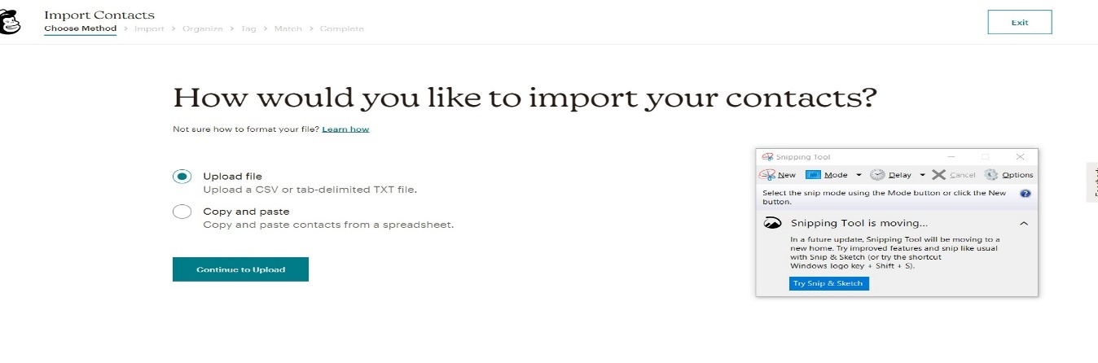
- Choose Upload file; and locate the file you would like to upload. Click continue.
- Organize your Contacts – choose “subscribe”. If this is your 2nd or 3rd or 4th upload, click on “Update any Existing Accounts”.
After completing your upload, it will take you directly to “creating a campaign” and you can begin your very first mass email.
**Remember to delete your excel spreadsheet from your hard drive.

