Profile: How to Pull a Patient List and Export into Excel Spreadsheet and Import into MailChimp
In Profile, go to Reports >> Stored Queries and create a new search. Please note the photo below which shows the search peramiters.
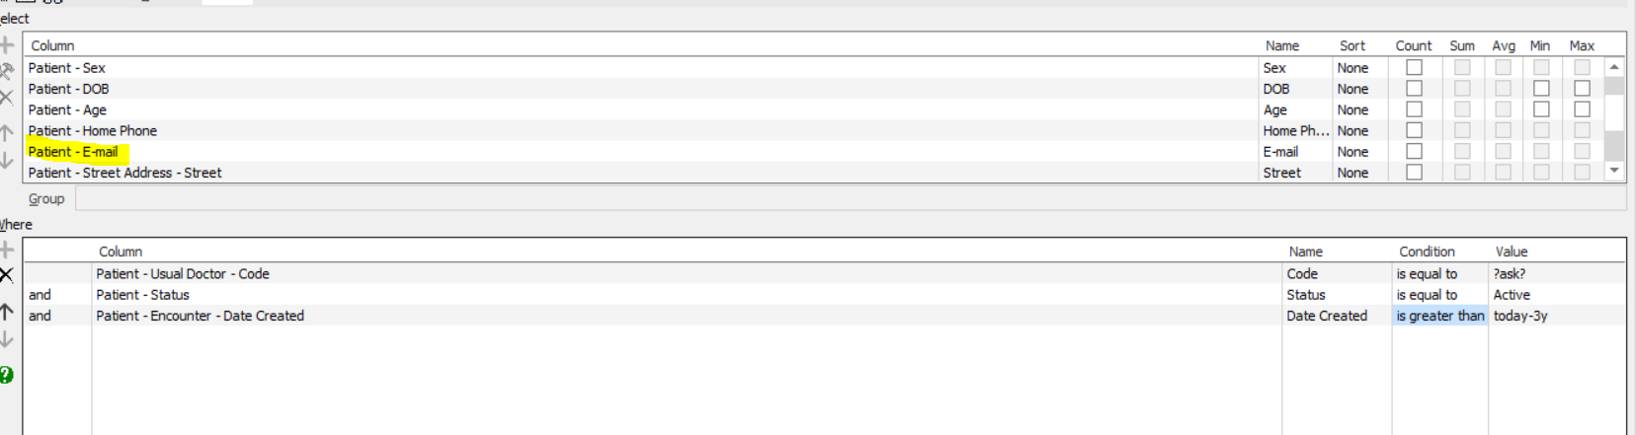
Make sure that you add the physicians’ initials in “Value” under Patient-Usual Doctor-Code.
Once you are satisfied with your search go to the top right green icon. Shown below.
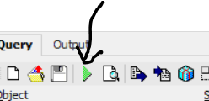
Click on this icon and a list of patients will show up.
Begin by clicking on the top patient to highlight. Hold down the “shift” button on your keyboard as you scroll to the bottom of your patient list. This will highlight all patients.
Go to Edit >> Copy
Open a new Excel Spreadsheet >> right click and paste into spreadsheet

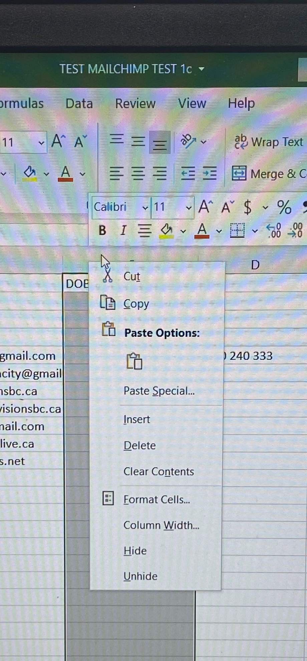
*Note the only data required for MailChimp is: First Name, Last Name, and Email address.
When you right click at the top of the spreadsheet (ie in the “D” column), you will see a drop down selection. Click on “delete”, and “delete column”. You can do this process for each column that you do not need in MailChimp. (See above snapshot)
When you are satisfied with the edited version of this spreadsheet then you can save it as a CSV file. See screen shot below which shows what to look for when saving a CSV file. (There are a few to choose from)
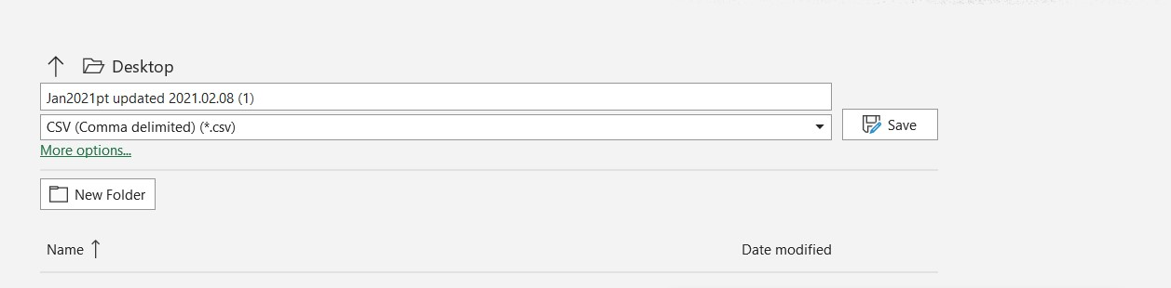
- From here you would open your MailChimp account. Click on “audience” which is on the left-hand side of the page. Click on “Manage Audience”, which is on the right-hand side of the page. Click on “Import Contacts”.
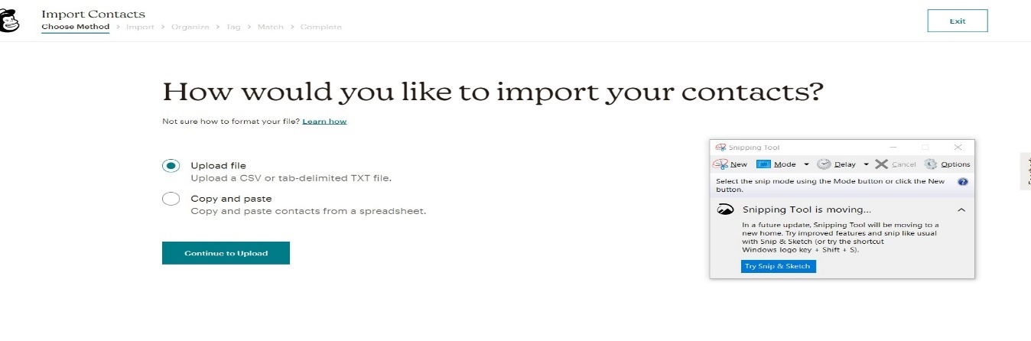
- Choose Upload file; and locate the file you would like to upload. Click continue.
- Organize your Contacts – choose “subscribe”. If this is your 2nd or 3rd or 4th upload, click on “Update any Existing Accounts”.
After completing your upload, it will take you directly to “creating a campaign” and you can begin your very first mass email.
**Remember to delete your excel spreadsheet from your hard drive.

