

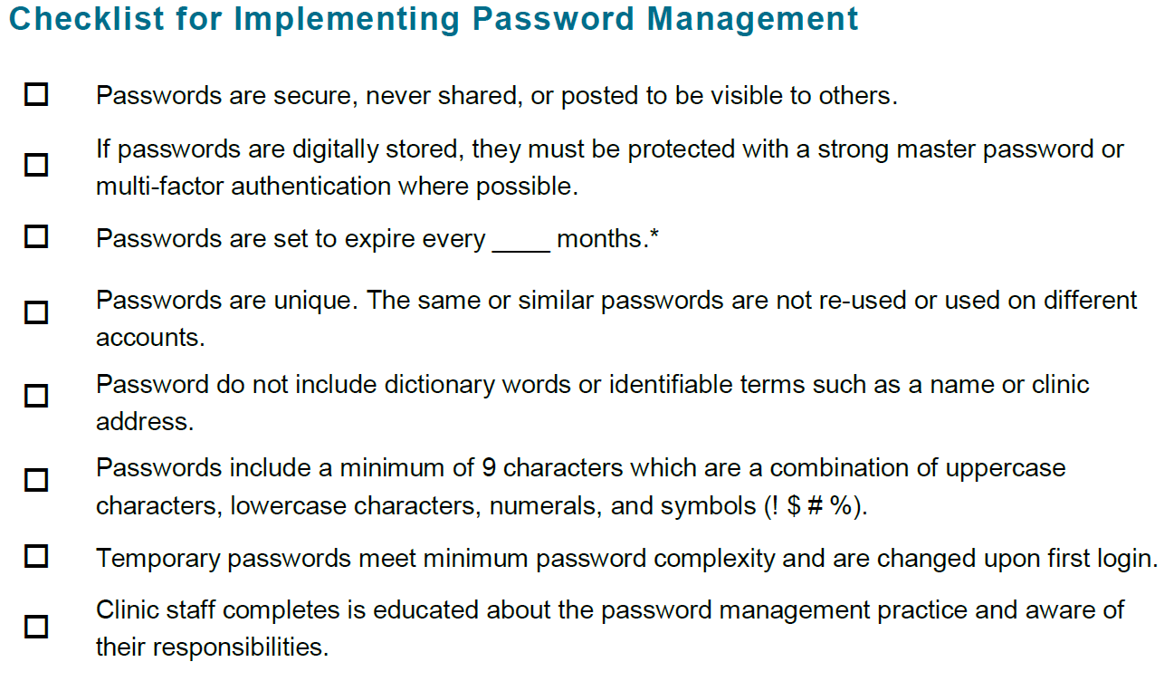



|  |  |  |
| --- | --- | --- |
| **Name** | **Date** | **Signature** |
|  |  |  |
|  |  |  |
|  |  |  |
|  |  |  |
|  |  |  |
|  |  |  |
|  |  |  |
|  |  |  |
|  |  |  |