Oscar: How to Pull a Patient List and Export into Excel Spreadsheet and Import into MailChimp
At the top of the Oscar platform is “Reports”. Choose number 23 = Report By Template.

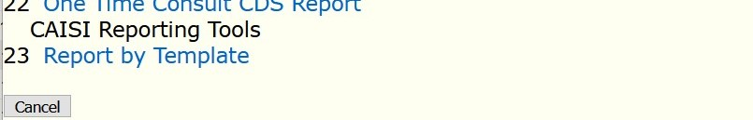

You will receive many options for reporting tools. You want to choose Number 11 = All Active Patients and Contact Information. Click on this report.

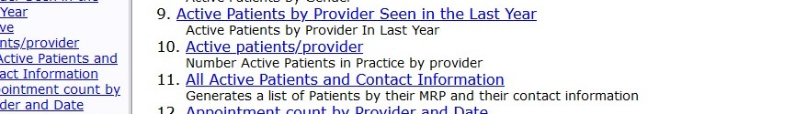

This is the report you want to run. Choose the provider and click on “Export to CSV”. (Make sure you have the current Microsoft Office on your computer so that it will go to an Excel Spreadsheet.

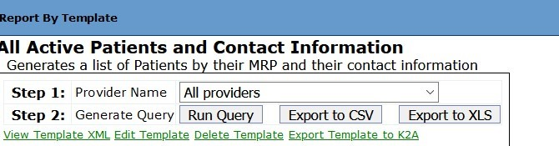

When you click on Export to CSV the patient list will automatically export into a Excel Spreadsheet. Once this is done, you will have the opportunity to “edit” the spreadsheet before saving it to export into Mailchimp.
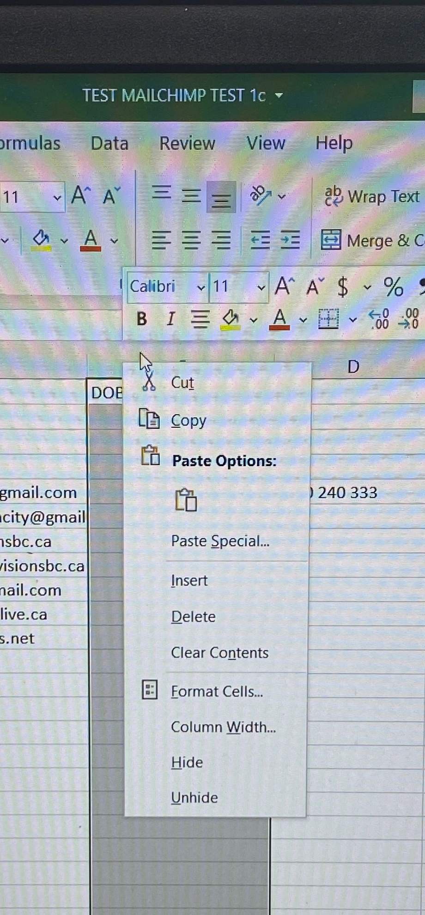
*Note the only data required for MailChimp is: First Name, Last Name, and Email address.
When you right click at the top of the spreadsheet (ie in the “D” column), you will see a drop down selection. Click on “delete”, and “delete column”. You can do this process for each column that you do not need in MailChimp. (See above snapshot)
When you are satisfied with the edited version of this spreadsheet then you can save it as a CSV file. See screen shot below which shows what to look for when saving a CSV file. (there are a few to choose from)
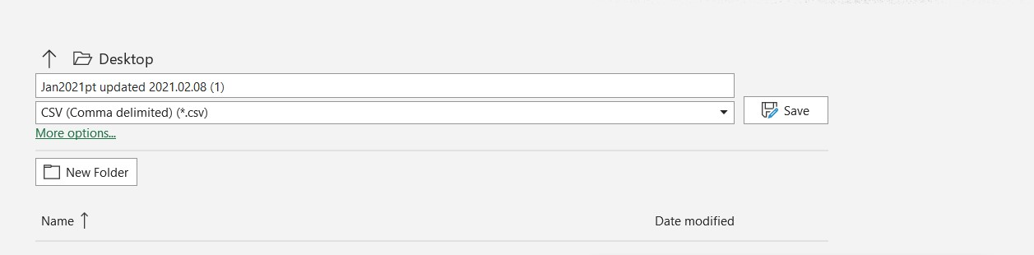
- From here you would open your MailChimp account. Click on “audience” which is on the left-hand side of the page. Click on “Manage Audience”, which is on the right-hand side of the page. Click on “Import Contacts”.
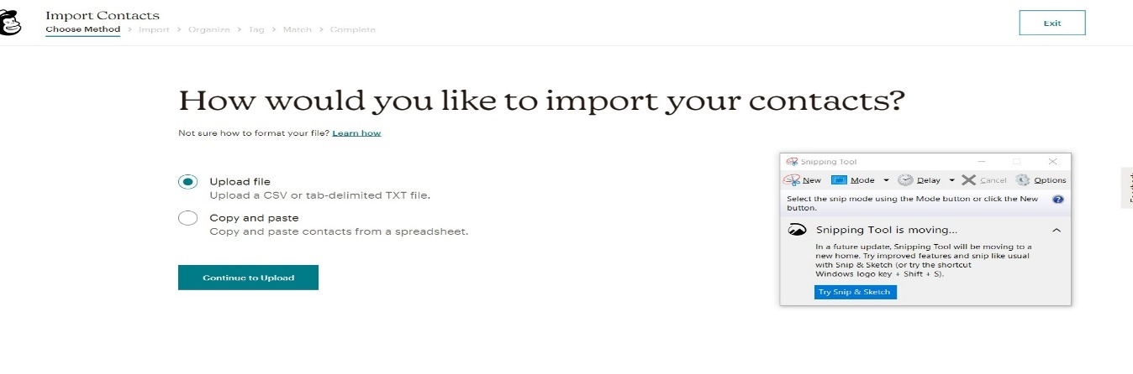
- Choose Upload file; and locate the file you would like to upload. Click continue.
- Organize your Contacts – choose “subscribe”. If this is your 2nd or 3rd or 4th upload, click on “Update any Existing Accounts”.
After completing your upload, it will take you directly to “creating a campaign” and you can begin your very first mass email.
**Remember to delete your excel spreadsheet from your hard drive.

