Online Security Course
DTO partnered with UBC CPD to provide an online course, which is free for anyone to use and physicians can earn a CME credit. (1.0 Mainpro+). Time required: approx. 45 min and can be completed over multiple visits.
Link to Course: https://ubccpd.ca/course/dtooc

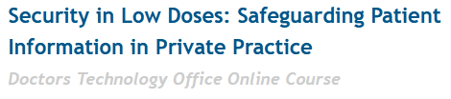
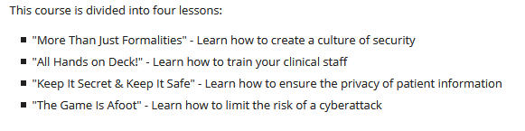
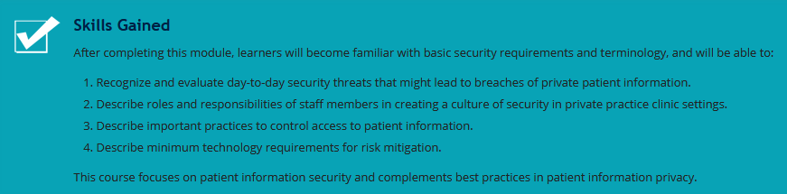

Name | Date Completed

