- Click on reports
- Open demographic box and select the status and primary provider
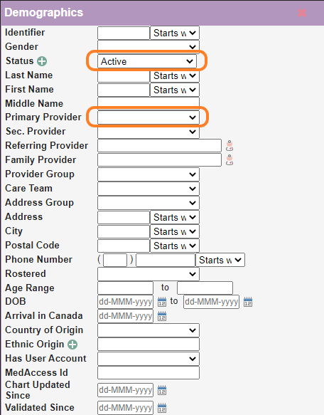
- Select the type from the drop down box – Email List (This will give you the list of patients for the provider you selected who have an email address)
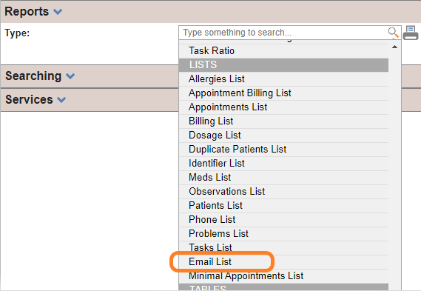
- Then select the to generate the list
- Open the list and delete the rows 1-3
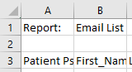
- Go back to the report window and select the type for Patient List
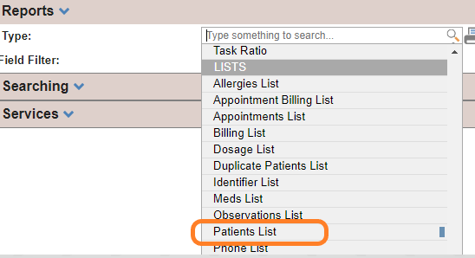
- Select the printer to the list
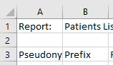
Delete columb B, then Delete C – This will leave the Chart numner, First name and Last name (3 columns)

Highlight all rows in column A, B & C, Right Click on the highlighted area and select “Sort A-Z”
Highlight all rows in columns A, B & C again, and delete duplicates. 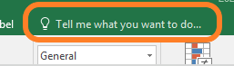 “Remove Duplicates”
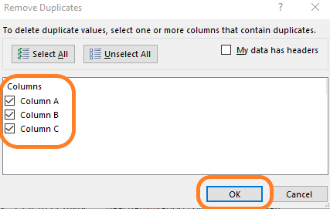

If not already sorted by email column, highlight the while email column (G) and Sort A-Z
Then you will see the group of patient names who do not have an email attached – this is your list of patients with no email on file.
(Some patients are showing emails on this list because the name from the “Active Patient List” was deleted when the duplicates were removed)

