1
Fraser Northwest Primary Care Network Period 8 Addendum Report
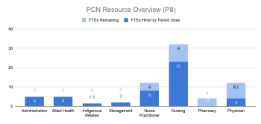
FNW PCN Performance Monitoring Summary 2
FNW Community Overview 3 Overview: Primary Care Provider Community Adds & Losses 4
Family Physician and Nurse Practitioner Contracts 5 Practitioner Reporting Feedback 6
Registered Nurse in Family Practices 7 RN In Practice Impact Stories 7
Allied Health (Clinical Counsellors) Supports - Contracted Agency 8
Allied Health (Clinical Counsellors) Supports - FHA MHSU 9 Mental Health Program Impact 10
Indigenous Related Supports 11 FNW Practice Support Program 11
Attachment 12 Attachment Hub Waitlist 12 Passive Attachment 13 Active Attachment 13 Attachment Coding (MoH) 14
Virtual Care Hub 15 Feedback from the Community 15 Physician Feedback and Engagement 16 Pathways 17 PCN Lessons Learned 18 Version - December 3, 2020
2
FNW PCN Performance Monitoring Summary
Work is underway between partner organizations to identify relevant indicators to measure and report on the following Primary Care Network Attributes:
PCN Attribute | Indicator Change (period over period comparison)
Attachment and Access to Primary Care | Exact metrics to identify indicators under development between FNW PCN partner organizations
Extended Hours | Exact metrics to identify indicators under development between FNW PCN partner organizations
Same Day Access to Urgent Care | Exact metrics to identify indicators under development between FNW PCN partner organizations
Advice and Information | Exact metrics to identify indicators under development between FNW PCN partner organizations
Comprehensive Primary Care | Exact metrics to identify indicators under development between FNW PCN partner organizations
Culturally Safe Care | Exact metrics to identify indicators under development between FNW PCN partner organizations
Coordinated Care | Exact metrics to identify indicators under development between FNW PCN partner organizations
Clear Communication | Exact metrics to identify indicators under development between FNW PCN partner organizations

Additional details and reporting measures will be shared in the next period report upon identification and discussion at upcoming PCN Partner leadership discussions.
Version - December 3, 2020
3
FNW Community Overview
FNW Division membership comprises approximately 450 physician and provider members. Although this number is large, 40% of FNW members have been in practice for 20+ years. This is a significant portion of the membership of FNW. Membership is, not surprisingly, largely made up of community Family Physicians with a similar number of locums and hospitalists comprising the bulk of the members. Year over year membership composition continues to show strong numbers for Physicians in their first 10 years of practice, the graph below represents the year over year membership composition based on members’ graduation year:
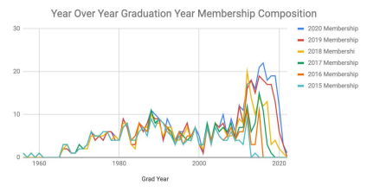
The average Blue Book Listings for Physicians in the FNW in 2017, 2018 and 2019 are represented in the chart below. It’s important to note that these numbers reflect Physicians in a variety of roles and providing primary care services in a number of different practice types - i.e. Family Practice, Walk-In Clinic, Hybrid, Locum, Residential Care, Hospitalist, Maternity, Addictions and a number of others practice types.
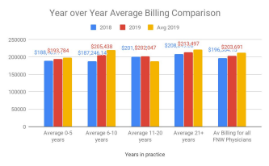
Version - December 3, 2020
4
Overview: Primary Care Provider Community Adds & Losses
Since the inception of the FNW PCN in April 2019, there continues to be primary care providers joining and leaving the community. The visual below denotes the addition of primary care providers (including both Family Physicians and Nurse Practitioners) to the FNW communities; the leaves of primary care providers (including retirements and other leaves); and the correlating attachment based on data collected from the FNW Attachment Hub. A detailed breakdown of the projected retirements can be found later in this section.
 | 2019 | 2020 (as of Period close)
Provider Adds | 10 | 6
Provider Losses | 15 | 27
Net Loss/Gain | -5 | -21
Attachment* | 856 | 2010

*Attachment numbers pulled from FNW Attachment Hub
Work is underway to welcome potential International Medical Graduates (IMGs) Return of Service (ROS) from the UBC program and the Practice Ready Assessment (PRA) program into community practices to take on a panel for longitudinal practice. 2 Physicians from the PRA program have been matched with FNW communities with the clinical assessment commencing in Spring 2021. With regards to the ROS program, 2 Physicians and 2 clinics have been successfully matched. It’s anticipated that these 2 Physicians will start in FNW communities in Summer 2021.
The number of physicians retiring and/or leaving the community continues to grow with those leaving citing high costs that the FFS compensation model currently can’t meet with how some family physicians practice. Since 2016, there have been approximately 77 physicians leaving the community with 11 physicians leaving in 2019 and an additional 27 leaving in 2020 already. Previous data shared in the report below was not inclusive of all retirements and losses in the community, updated data is shared in the graph below.
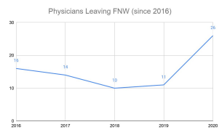
Projected retirements in the next year are set at 7 with a five year forecast of 25 family physicians retiring out of the FNW communities. This projection is an estimate and is based on an estimate that approximately 10% of our members that are 21+ years in practice will retire between 2020-2024 as we have 173 members that are 21+ yrs.
Supportive resources such as RNs in Practice, access to rapid clinical counselling resources and practice Version - December 3, 2020
5
improvement support are paramount to retaining the current physicians in the FNW, and recruiting future physicians to practice in these communities.
Family Physician and Nurse Practitioner Contracts
Collaborative work between the FNW, FHA, HealthMatch and the Ministry of Health is vital in order to support increased FP and NP resources in the FNW communities. In Period 8 (October 16 - November 12), clinic openings decreased slightly to 18.6 FTE. Table 1 below provides a status overview and update on the breakdown of the NP and FP contracts by PCN within the FNW:
 | Referrals |  | # in the  process of  finding a  match | # of introductions between provider and clinics | # of contracts signed
 | # of New  Referrals | Running Total of Referrals since  PCN Launch
Family Physician | 2 | 64 | 0 | 0 | 0  PCN Launch  Total: 4
Nurse Practitioners | 2 | 39 | 6 | 3 | 0  PCN Launch  Total: 8

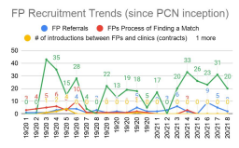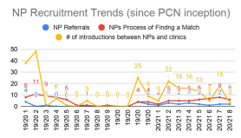
The number of active postings on HealthMatch BC for FPs for both FFS or contract positions decreased in this period to 40 active postings by period close. Opportunities for these postings include: locum and permanent part-time and permanent full-time in the FNW.
Fee For Service (FFS) opportunities and engagement efforts are underway on an ongoing basis and in this period, there were 20 new introductions between FPs and practices for FFS opportunities such as locum, permanent part-time and permanent full-time.
Version - December 3, 2020
6
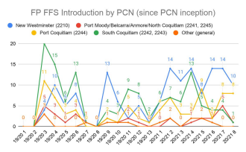
Practitioner Reporting Feedback
As part of the ongoing development around sustainable contract management, partner organizations co-developed reporting templates that were distributed to all PCN contracted Family Physicians and Nurse Practitioners to support accountability around contract reporting and quality improvement. Providers were asked to share their satisfaction levels and based on the reports received at the time of writing this report,
aggregated data reflects an average satisfaction levels for the month of October to be 7 out of a scaling of 0-10 (0 being very unsatisfied and 10 being very satisfied). Satisfaction-level trends over time are noted below since the FNW PCN inception.
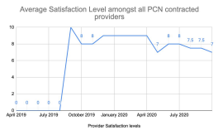
These providers also provide feedback around what’s working well, ongoing challenges and what they’d like to share in order to support partner organizations’ understanding of the experience providing longitudinal care in a contract-funded environment. Feedback collected in October notes the following lessons learned
1. Patient volume and growing providers’ patient panel is at the forefront for some and providers are eager to meet contract panel obligations while providing accessible care to their patients.
2. Billing rejections for contracted providers are arising; specifically around ICBC and WorkSafe BC related billings. One provider noted some of the issues regarding teleplan billings have been recently solved.
Version - December 3, 2020
7
Registered Nurse in Family Practices
In Period 8, there are 22 family practices that now have a nurse with 2 additional RNs in orientation at period close. An additional 2 RNs have accepted offers with later start dates in Fall 2020. The YTD distribution across the PCN’s are:
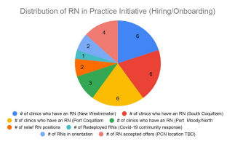
Accurate encounter code data is vital to the ongoing implementation of the RN in Practice Initiative and it’s important that PCN funded resources do not add to the workload, but reduce it. Clinics that receive billing rejections have noted that correcting these are increasing the overall workload as opposed to reducing it. The continued rejections have been affecting the Family Physicians, Nurse Practitioners, RNs and practice staff in these clinics and some rejections date back to the summer. Collaborative work between the Division team, the PCN contracted providers and the support team from the MoH began and a potential solution to eradicating the continued billing rejections was found. This solution is going to be tested in a few clinics before being rolled out to all clinics with PCN funded resources.
RN In Practice Impact Stories
Recently an RN moved out of the primary care setting and back into an acute setting; however before moving on, they provided an overview - from their perspective - of the benefits of an RN in a family practice setting. Below are a few points that were mentioned regarding the positive impacts that an RN can have in a primary care setting:
● The RN works in a team-based care model, focusing on a patient-centered approach and reaching out to other health care professionals in the community
● The RN locates and provides information on community resources to the health care professionals in the clinic
● The RN liaises with Home Health, Public Health, Mental Health teams to gather information on clinic patients that have been referred and/or have seen these health care teams in the community; provides updates to Physicians based on these investigations into current care and treatment of these patients
● The RN provides in clinic/telephone assessments for patients who require weekly/monthly follow-ups, but do not necessarily need to see their family practitioner · The RN provides chronic disease management/support – this includes a thorough systems assessment of the patient, which allows the physician to see areas of strength and areas of concern
Version - December 3, 2020
8
● The RN provides baseline assessments for prenatal women (obtaining weight, height, ensuring dating ultrasounds and prenatal lab work are ordered/in progress)
● Continuity of Care – The RN maintains a relationship with patients on an ongoing basis – weekly or monthly follow ups related to their chronic health challenges and needed supports
This story explores the impacts that the Registered Nurse in Practice Program has had on Physicians and members of the clinic’s care team.
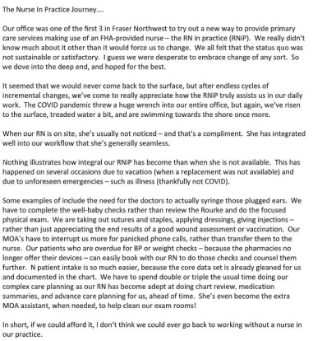
Another clinic shared an example of their RN knowing sign language and supporting communication between providers and patients who may be deaf and/or hard of hearing. This skill works to reduce barriers for access for both providers and patients and is an example of strengthened team-based care within a PMH.
Allied Health (Clinical Counsellors) Supports - Contracted Agency
The number of referrals for this reporting period decreased along with the average length of time for patients to be seen whereas the number of referring clinics grew when comparing numbers from the last reporting period. The table below details the change over the last period to the current period:
Version - December 3, 2020
9
 | Previous Period (P7) | Current Period (P8) | Difference
# of Referrals | 84 | 77 | ↓
# of Referring Clinics | 22 | 27 | ↑
Average length of time for patients to be seen (days) | 38.3 | 35.6 | ↓

The chart below details the period over period trends for the # of referrals, # of referring clinics and the average length of time for patients to be seen after first contact since PCN inception.
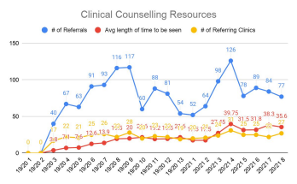
Allied Health (Clinical Counsellors) Supports - FHA MHSU
A FHA resource developed to support access to mental health and substance use supports for FNW community physicians launched where 4 FTE Mental Health Clinical Counsellors are available to FNW physicians to support providers and patients as part of the Primary Community Care team. Details on the number of referrals can be found in the table below:
 | Previous Period (P7) | Current Period (P8) | Difference
# of Referrals | 67 | 52 | ↓
# of Referring Clinics | 19 | 18 | ↓

In Period 8, referrals to the program decreased compared to the previous period. Patients are able to self-refer as there has been increasing concerns around anxiety and depression as it relates to the current pandemic situation. Virtual counselling have been developed in the FNW to support ease of access for patients and physicians given the current environment. Of the 52 referrals, 5 of them were self-referrals citing covid-related concerns.
Version - December 3, 2020
10
Work is underway between partner organizations to develop and implement patient feedback surveys to get a sense of the impacts that both mental health programs have had on patients in the FNW communities.
Mental Health Program Impact
Through the co-development of these programs, the intention was to increase patient and physician access to rapid counselling supports given the high waitlist for existing community supports. This intent in turn decreases the burden in caring for these patients that is placed on family physicians which then could create increased capacity. Year over year comparative data provided from the Ministry of Health which looked at the MSP billings for those physicians in the FNW who have referred to this program details that although there has been an increase in the number of physicians billing, the counselling fees, distinct patients and average counselling visits/provider have all decreased. As a note, the MSP data is not fully complete until after 90 days. The tables below shows the year over year comparison broken down by month for:
● The # of practitioners billing for counselling fees
● The # of patient visits from the counselling fees
● The # of distinct patients
● The # of counselling visits/provider
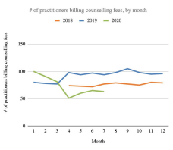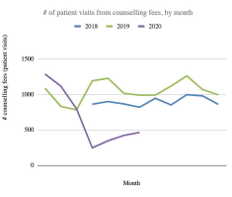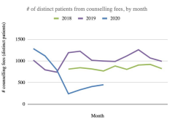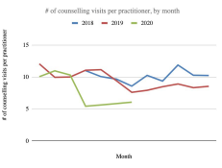Version - December 3, 2020
11
Indigenous Related Supports
As one of the partner organizations in the Fraser Northwest Primary Care Network, Kwikwetlem First Nation has worked to identify the resources needed in their First Nation Community. These resources will work to support increased attachment and access to primary care services for the Nation, as well as surrounding urban and away from home Indigenous population.
The Kwikwetlem Primary Care clinic opened mid-October for community members. The clinic is staffed with two doctors (52 FP Sessional), an MOA, a Nurse Practitioner, a Registered Nurse, elder home support worker (0.5 FTE) and an Aboriginal wellness advisor (1.0 FTE).
The members of the Kwikwetlem First Nation are accessing the services from the clinic. The soft opening has been a great success according to the team and the community members accessing services. The Physicians are in on Tuesdays. There is also a Nurse Practitioner in the clinic on alternate Fridays. The Community Health Nurse is in 2 days/week to do drop-in for Kwikwetlem First nations members for injections, medical assessments, referrals, wellness checks, blood pressure, blood glucose checks, wound care and assisting with the Physician of the day’s phone calls.
The elder home support worker is serving three elders and has two elders waiting to be seen. Now, they are in 3 days/week and help the elders with meals, housework, shopping, medical appointment transport for specialist appointments, referral for specialists, and when it can be done safely planning activities for the elders in the community hall.
The Aboriginal wellness advisor has assisted the Director of health to assess the wellness needs of the community. They are currently working on meeting the needs of the community by seeking community partnerships with local organizations. In addition, the wellness team is actively seeking grants for wellness programs. Lastly, the Aboriginal wellness advisor worked with the Nurse to hand out food to the community members and provide lunch for the children, youth, and elders.
FNW Practice Support Program
The Practice Support Program (PSP) provides family physicians the opportunity to “practice more efficiently, focus on providing proactive care, and work towards adopting attributes of the Patient Medical Home.” PSP and the FNW Division completed the two cohorts of the Quality Improvement Small Group Learning Session (SGLS) that were delivered virtually to FNW physician members and was co-facilitated by a PSP representative and a community Physician. As well, multiple EMR SGLS took place and an additional one was planned for the next reporting period. As reported by PSP, most of the PMH/PCN work that is taking place relates to:
● Panel Management
● Panel Maintenance
● Patient Experience Tools
● EMR Skills Assessments
A recent EMR SGLS also took place in this period. Below is the month over month comparison from the previous report shared:
 | # of  MSOC  Physician | # of PMH  Assessments completed | % started  Panel  (MSOC) | %  Completed Panel | Started  Panel | Working on Phase 1 | Working on Phase 2 | Working on Phase 3 | Workbook  Complete

Version - December 3, 2020
12
 |  |  |  | (MSOC)
Previous  month  (September) | 169 | 118 | 64% | 54% | 109 | 11 | 3 | 4 | 91
Current  month  (October) | 162 | 118 | 67% | 57% | 109 | 9 | 2 | 6 | 92
Change | ↓ | = | ↑ | ↑ | = | ↓ | ↓ | ↑ | ↑

Attachment
Attachment Hub Waitlist
The FNW Division Attachment Coordinator continues to support the attachment between the public seeking a FP and family physicians accepting new patients. It is important to note that these numbers do not capture the full scope of the community attachment taking place as there are primary care providers attaching patients without connecting with the Attachment hub. True attachment data may be reflected in the 0$ MSP fee codes; however, work to implement those across the region is an ongoing process between partners. Since the inception of this dedicated resource to the community in Summer 2019, the waitlist for patients continues to grow and recent data provides an indication of the average wait time of those who have been attached broken down by community:
Community | Average Wait Time | # of people attached
New Westminster | 96 | 188
Port Moody | 92.9 | 49
Coquitlam | 17.6 | 215
Port Coquitlam | NA | NA

When people join the Attachment Hub Waitlist the referral source is also collected, below is a breakdown of the main referral sources by period since FY 20/21 Period 4 as a data is currently available for these periods:
Version - December 3, 2020
13
Passive Attachment
During this reporting period, the table below details a breakdown of the attachment work that took place by the Attachment Hub:
 | New Westminster | South  Coquitlam | Port  Coquitlam | Port Moody, Anmore,  Belcarra, North Coquitlam
# of providers who accepted patients | 2 | 1 | 0 | 1
# of patients  attached | 72 | 4 | 0 | 48
# of patients waiting to be attached | 1177 | 1048 | 621 | 493

There continues to be an increase in patients waiting to be attached in this period compared to previous reporting periods which is likely a result of a recent public engagement campaign in the local New Westminster and Tri-Cities newspapers.
Version - December 3, 2020
14
Active Attachment
Recently, with the introduction of additional mechanisms that support the coordination of care between systems, an opportunity was identified to build on and actively link these with the FNW Attachment Hub. Unattached moms and babies seeking prenatal and postnatal care at the FNW New Mom/Well Baby Clinic (stationed at a local clinic in Port Coquitlam) are now directly linked with the Attachment Hub and upon discharge from this clinic are connected with a Family Physician in the community. Additionally, work has taken place to connect unattached patients recently discharged from the hospital to a Family Physician. Immediate follow-up care is provided through the Acute Discharge Program with the intention that longitudinal care will be provided by the attaching Physician. The visual below reflects the New Mom/Well Baby and Acute Discharge programs October referral data:
Work is currently underway with FHA Home Health to identify and establish workflow processes for attachment between patients that may be medically complex and/or frail with a Primary Care provider.
Attachment Coding (MoH)
Attachment data from the MoH has recently become available providing an analysis of the breakdown of attachments and detachments based on provider type and the associated patient counts. Data was shared starting from January 2020 reflecting the trends of provider counts and patient counts - broken down by type of provider and # of times that the specific encounter code was used. The visuals below reflect the month over month trends for both distinct providers (Family Physicians and Nurse Practitioners) and distinct patients (that are attached/unattached to a Family Physician or a Nurse Practitioner):
Version - December 3, 2020
15
Virtual Care Hub
On November 9th, the FNW Virtual Care Hub was launched to the public. This clinic will continue to be introduced through a phased approach with current access being 5 days a week between 9-1; however, it’s
intention is to provide 7 days/week access to routine and non-emergent care to patients in the FNW communities. This care hub builds off of the current Acute Discharge Program and will continue to collaboratively work with the local hospitals, FNW PCN resources and the FNW Attachment Hub. Patients are able to access this service whether they’re attached or unattached. The three main program objectives are:
1. To reduce incidence of hospital readmissions and ER visits by providing timely, accessible and comprehensive follow-up care post-acute discharge for patients who:
- Are not attached to a longitudinal primary care provider
- Are attached, but whose primary care provider is unable to provide follow-up care
2. To facilitate attachment to continuous primary care for patients without a longitudinal provider 3. To provide access to a virtual care platform for patients seeking after hours care
Achieving the above will aim to reduce acute care costs through
● early identification of complications following discharge from hospital
● reduction of unnecessary ER visits through diversion to an after hours virtual service ● Attachment with an FP may reduce costs given previously patients seeking care may go to ER; now, that same may be provided by FP
Version - December 3, 2020
16
Feedback from the Community
Preliminary work is underway to develop a PCN related public engagement strategy that collects feedback and stories from patients to better understand what primary care healthcare supports are integral to their continued access and overall health. Engagement work is currently underway to identify opportunities for people in the community to provide feedback on accessing healthcare services for their needs. Responses from the public survey decreased in October with a total of 60 new responses. Main themes surrounded patients looking for a Family Physician and the FNW Attachment Hub Coordinator is working to connect with these people.
Resources have been launched related to public engagement through various FNW Division social media strategies where the division’s communication team is utilizing multiple social media platforms. In September they’ve recorded the following changes in public engagement through the social media platforms:
Channel | # of Posts | Engagements | Followers (+/-)
All Channels (Facebook,  Instagram, Twitter, LinkedIn) | +134 | 630 | +47

Physician Feedback and Engagement
Feedback from physicians, partner organizations, internal and external stakeholders has also been collected and key themes from this reporting period that have emerged include:
● In relation to the FP/NP contracts:
○ Division connecting with contracted practitioners around any support and questions/clarifications that may have emerged since being in practice.
○ Division connecting with MoH around billing rejections and identification of strategies for improvement
● In related to the RN in Practice Initiative:
○ Billing questions around virtual care between the RN and clinic Physicians
○ Physician Leads are identifying and sharing Most Significant Change stories around the RN in Practice and the impacts that the provider can have on patients that enhance access.
● In relation to the other Allied Health Professional positions:
○ Communication with partner organizations around support from Home Health and identification of strategies for strengthening relationships between primary care and community care
Physician engagement for this reporting period includes:
Version - December 3, 2020
17
Additional engagement support provided to FNW physicians is the website development as supported by a Digital Content Coordinator. The move to providing primary care services in a virtual setting continues to grow
and expand. A full list of the clinics in the FNW and their associated websites can be found by clicking here. The chart below details the main steps in clinic website developments period by period.
Website analytics that looks at the total page views and visits from the public on popular links from each clinic website and approximately 21.4% of the total ‘clicks’ were on Booking an Appointment.
Version - December 3, 2020
18
Pathways
Pathways is a virtual directory that allows local Family Physicians and providers to identify and access resources, supports and services for their patients on a variety of healthcare related concerns. It is a tool used by Physicians and Specialists for referral resources, wait times, and has been proven to play an important role in the coordination of care between providers. Data pulled from the FNW Pathways site from August 2019 shows the page views of PCN related referral supports as well as details the rapid increase in Covid-19 supports since March 2020.
PCN Lessons Learned
1. For FNW PMHs to be eligible for in-practice allied health support, all members of the PMH must be a member of the Division.
2. Work is underway between partner organizations to develop and identify information required to set up Clinic Payee information as it relates to RN in Practice encounter code reporting.
Version - December 3, 2020

