Developing Your COVID-19 Safety Plan

All employers have been ordered to create a COVID-19 Safety Plan by the Provincial Health Officer. WorkSafeBC has created a template which provides a step-by-step checklist and includes topics such as assessing COVID-19 risk in the workplace, protocols to reduce risk, and developing policies to protect the safety of patients and staff. Doctors of BC expanded on this to provide recommendation specific to physicians in community in their guide “The Doctors is In: Recommendations for Expanding In-Person Care in Community Practice”.
We recognize you have probably already received this information but wanted to share a slightly adapted version with local information and Interior Health specific resources for community providers in the Thompson Region. We hope that this can function as template for your COVID-19 Safety Plan. You can delete or add anything to make the Safety Plan specific to your practice. We have also combined all the linked resources in one package – they are included as an appendix. We hope this saves you from having to download and save multiple documents.
If you have any questions or concerns in filling out this document, please contact your network coordinator at the Division or your Practice Support Program coordinator and we can help you or direct specific questions to WorkSafeBC if needed.

COVID-19 Safety Plan

Clinic Name:

Clinic Address:

Date Completed:

Signed off (if needed)

__________________________ ________________________
Name Name

Step 1: Assess the risks at your workplace
The virus that causes COVID-19 spreads in several ways. It can spread in droplets when a person coughs or sneezes. It can also spread if you touch a contaminated surface and then touch your face. The risk of person-to-person transmission increases the closer you come to other people, the more time you spend near them, and the more people you come near. The risk of surface transmission increases when many people contact the same surface and when those contacts happen over short periods of time.

If you are struggling to undertake this assessment, please reach out to the Division or WorkSafeBC for assistance.

Working with your staff and other team members, discuss the following and document what you find:
- We have involved frontline workers, supervisors, and the joint health and safety committee (or worker health and safety representative, if applicable).
- We have identified areas where people gather, such as lunch rooms, exam rooms, waiting rooms and meeting rooms.
- We have identified job tasks and processes where individuals are close to one another and/or members of the public.
- We have identified the office, medical and other equipment that staff and team members share while working.
- We have identified surfaces that people touch often, such as doorknobs, elevator buttons, and light switches.

Step 2: Implement protocols to reduce the risks
A number of guidance documents are available for community-based physicians to help minimize risks of transmission. These may be updated—or others may be added—in the future:
- The Provincial Health Officer’s order from May 15th.
- the College’s Guidance on providing in-person care during COVID-19
- the BCCDC’s COVID-19: Infection Prevention and Control Guidance for Community-Based Physicians, Nursing Professionals and Midwives in Clinic Settings
- WorkSafeBC’s Health Professionals: protocols for returning to operation

Help your staff and other team members by ensuring everyone is aware of office protocols and changing practices.
- Document office protocols in an employee handbook with instruction guides (i.e. scripts for communicating with patients and cleaning protocols—see below) and keep these up to date.
- Re-evaluate staff sick time policies to prepare for greater absences and align with COVID-19 recommendations.
- Educate staff on changing office practices and procedures to minimize COVID transmission and exposure (i.e. cleaning protocols,(pg. 1-2) altered patient flow) with refresher training as needed.
- Cross-train staff in essential tasks to prepare for absenteeism.
- Educate staff on how to communicate the new office protocols to patients (e.g. waiting in their cars or outside staging areas prior to entering the clinic, how to check-in if not in-person, maintaining physical distancing in waiting rooms, calling prior to appointments to inquire about respiratory symptoms, etc.).
- Review proper office and medical cleaning routines with janitorial staff/contractors.

Reduce the risk of person-to-person transmission
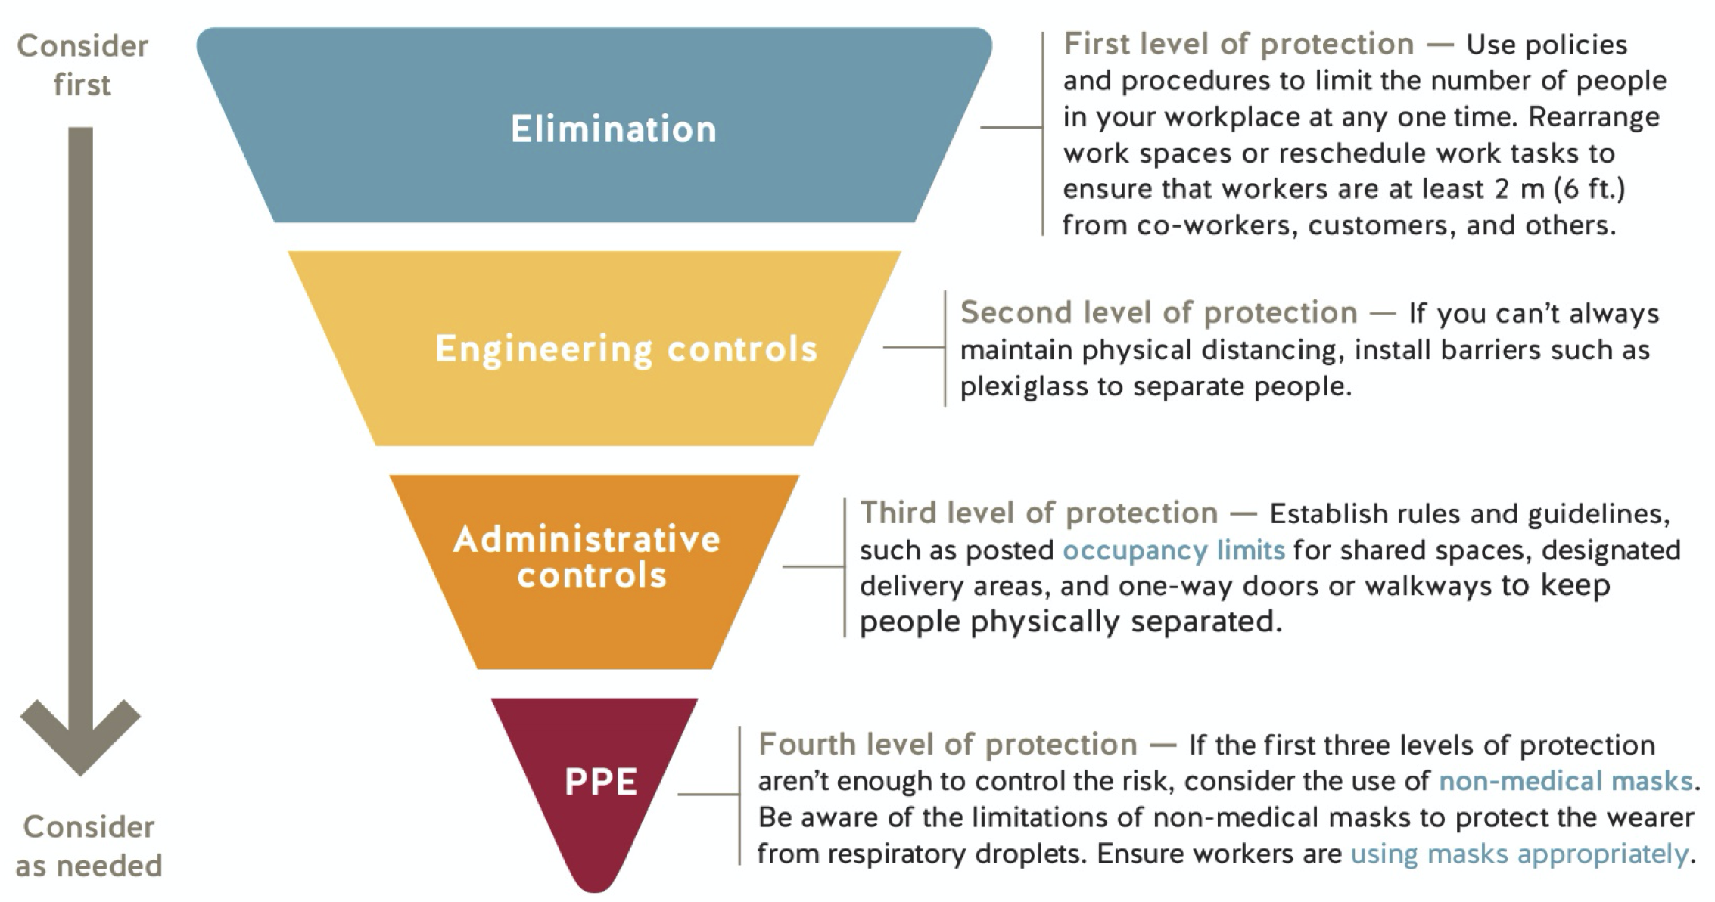
Source: WorkSafeBC COVID-19 Safety Plan Template

First level protection (elimination)
- We have established and posted an occupancy limit for our premises. [Public Health has developed guidance for the retail food and grocery store sector that requires at least 5 square metres of unencumbered floor space per person. This allows for variation depending on the size of the facility, and may be a sensible approach for determining maximum capacity for employers from other sectors that do not have specific guidance on capacity from Public Health.]
- In order to reduce the number of people at the office, we have considered work-from-home arrangements, virtual care, rescheduling work tasks, and limiting the number of staff and patients in the workplace.
- We have established and posted occupancy limits (pg. 3) for common areas such as lunch rooms, examination rooms, waiting rooms, washrooms, and elevators.
- We have implemented measures to keep staff and others at least 2 metres apart, wherever possible.

In developing your safety plan, consider the following and document the measures you are using to maintain physical distance in your practice:
- We have scheduled staff on a “team” basis: if one team becomes infected, this will minimize risk to staff on other teams.
- Where possible, staff will maintain physical distancing (e.g. avoid eating meals together, will increase the space between desks/workstations or alternate which desks/workstations are used).
- We have a sign on the door indicating patients should wait in their cars/outside when they first arrive and call us to check-in. This is reinforced by a message on our website and telephone system. We have emailed our patients (pg. 4) to let them know all the changes taking place in our office and what to expect.
- We will call patients or send them an SMS message when we are ready for them to come in.
- We have allocated a limited number of appointments per day, based on 1 per hour (modify to suit) AND/OR we have staggered appointments to allow for physical distancing in common areas.
- We have placed occupancy limits on our waiting room and ensured chairs are at least 2 metres apart OR we have eliminated patients waiting in our waiting room entirely—they will immediately be taken back to an examination room.
- We no-longer accept “walk-in” appointments. There is a sign on the door informing patients that no walk-ins are being accepted and redirecting them to our website or to a phone number. This message is also on our website and phone system. Patients can book a same day virtual appointment. They will be screened and an in-person appointment offered if appropriate.
- All patient appointments will take place via phone or video. If required and appropriate, a scheduled in-person appointment will be offered.
- We will only allow patients with scheduled appointments themselves to enter the office. We will make exceptions for pediatric patients or caregivers if necessary (judge as you see fit).
- Scheduled appointments for those at higher risk (e.g. immunocompromised, multiple comorbidities or the elderly) will be done in the morning, with normal risk patients seen later in the day, and any higher risk patients (if those are seen in the clinic) at the end of the day. This has been communicated to all staff.
- We have limited surfaces that allow for physical contact:
  - Removed magazines, toys and clipboards from waiting rooms and exam rooms;
  - Installed contactless doors (or propped doors open) and garbage bins (or removed lids);
  - Removed extra chairs from examination rooms.
- We have developed pick-up and drop-off protocols that eliminate people coming into the office:
  - When possible, pick-ups and drop-offs will be done outdoors to prevent the need for patients to enter the clinic and to minimize in-person contact as much as possible;
  - We have reduced the materials available for pick-up and drop-off to minimize non-vital in-person contacts.

Second level protection (engineering)
Although the requirements and limitations of each office are unique, general recommendations to consider include the following.
- We have installed barriers where workers can’t keep physically distant from co-workers, customers, or others.
- We have included barrier cleaning in our cleaning protocols.
- We have installed the barriers so they don’t introduce other risks to workers (e.g., barriers installed inside a vehicle don’t affect the safe operation of the vehicle).

In developing your safety plan, consider the following and document the measures you are using to engineer physical distance in your practice:
- We have indicated increments of 2 metres in front of the front desk.
- We have implemented a telephone check-in system OR we have implemented an online check-in system.
- We have set up a one-way directional flow through the office marked with arrows.
- We have set up a dedicated examination room with nearby PPE for patients with respiratory symptoms (if you are seeing these patients in your practice).
- We have set up a second entrance with short travel to the dedicated examination room for patients with respiratory symptoms (if you are seeing these patients in your practice).
- We have inspected and repaired all infrastructure systems (i.e. HVAC, water system, electrical system).
- We have increased the rate of air exchange/ventilation if possible; especially to fresh air if possible, avoiding recirculated air.

Third level protection (administrative)
Training your staff, yourself and your colleagues in safe work practices is key to prevent transmission of COVID.
- We have identified rules and guidelines for how staff and team members should conduct themselves.
- We have clearly communicated these rules and guidelines to staff and team members through a combination of training and signage.

In developing your safety plan, consider the following and document the rules and guidance you are using in your practice:
- We have scheduled staff on a “team” basis: if one team becomes infected, this will minimize risk to staff on other teams.
- If sick, physicians and team members must remain at home. They may continue to provide patient care via telephone or video.
- All staff will perform hand hygiene and don appropriate PPE (i.e. a surgical mask) immediately upon entering the office. The BCCDC Hand Hygiene poster (pg. 5) is being used to educate staff and team members. WorkSafeBC also has a hand washing guide (pg. 6)
- All staff will clean their hands frequently—as this is the best thing anyone can do to decrease the transmission of COVID.
- We will conduct temperature checks upon arrival and ensure all staff and team members continuously self-monitor for symptoms. We will use the Alberta Health Services Daily Fit for Work Screening tool (pg. 7) and accompanying instructions.(pg. 8-12)
- We have prepared to cross-cover staff or team members who are ill or quarantined:
  - In smaller offices, if possible, form a “pool” of available staff with nearby offices using the same EMR.
  - In larger offices, setup “teams” with staff and team members that don’t work at the same times in-office—if one team becomes infected, this will minimize risk to staff on other teams.
- We have put up laminated signage in the areas frequented by patients (e.g. washrooms and above examination room sinks) outlining the appropriate hand washing protocols, (pg. 5, 6) alerting high-risk patients (pg. 13) (i.e. respiratory symptoms, recent travellers) to notify staff immediately, cough etiquette, etc.
  - If paper signage is used, we will date when it should be discarded (monthly).
  - If laminated signage is used we will wipe it down regularly.

Fourth level protection (PPE)
- We have reviewed the information on selecting and using PPE and instructions on how to use appropriate PPE.
- We understand the limitations of masks and other PPE. We understand that PPE should only be used in combination with other control measures.
- We understand that if PPE is not available, staff and physicians are not expected to risk their own health by providing in-person care.
- We have trained staff and team members to use PPE properly, following manufacturers’ instructions for use and disposal.

In developing your safety plan, consider the following and document the rules and guidance you are using in your practice:
- We are following the PPE guidelines for (asymptomatic OR both asymptomatic and symptomatic) patients in community, as recommended by the BCCDC and/or our Regional Health Authority (e.g. Interior Health Community PPE Guidelines).(pg. 14-16)
- OPTIONAL: As we perform aerosol-generating medical procedures we will use full PPE following BCCDC guidelines, including properly employed N95 masks.
- We will provide masks for symptomatic patients (if seen in-office) and instructions on how to wear them (pg. 17) OR through signage (pg. 18) on our door and messaging on our website and phone system
  - We will encourage patients to wear their own masks.
- We will keep our mask on at all times, and keep our hands away from our face. If we touch it or remove it, or it becomes soiled or wet, we will change it.

Reduce the risk of surface transmission through effective cleaning and hygiene practices
The COVID-19 virus can survive on some surfaces for many days, therefore cleaning and disinfecting measures should be heightened to minimize risk of transmission. As defined by the BC Centre for Disease Control (2020), cleaning is the removal of soiling while disinfection is the killing of viruses and bacteria, and is never used on the human body. When the term “disinfection” is used in this document, it is assumed that cleaning will occur prior to disinfection.

- We have reviewed the information on cleaning and disinfecting (pg. 1) surfaces.
- Our office has enough handwashing facilities on site for all our staff and patients.
- Handwashing locations are visible and easily accessed.
- We have policies that specify when staff and team members must wash their hands and we have communicated good hygiene practices to staff and team members. Frequent handwashing and good hygiene practices are essential to reduce the spread of the virus. [Handwashing (pg. 5, 6) and Cover coughs and sneezes (pg. 19) posters are available at worksafebc.com.]
- We have implemented cleaning protocols for all common areas and surfaces — e.g., washrooms, tools, equipment, vehicle interiors, shared tables, desks, light switches, and door handles. This includes the frequency that these items must be cleaned (number of times per day) as well as the timing (before and after clinic, after lunch, after use).
- Staff and team members who are cleaning have adequate training and materials.
- We have removed unnecessary tools and equipment to simplify the cleaning process – e.g., coffee makers and shared utensils and plates.

In developing your safety plan, consider the following and document the cleaning protocols you are using in your practice, including who is responsible for what and how often cleaning occurs:
- We have removed unnecessary items or items that are hard to disinfect from exam rooms and will only bring them into the room as necessary (e.g. tissue boxes, soft office furniture, any equipment not regularly used).
- We have placed the patient chair as far away as possible from the physician chair/stool in the exam room.
- In order to minimize exposure to patients, staff will provide verbal instructions—such as instructing patients in how to use a scale, baby weigh-station or wall-mounted measuring tape—instead of doing it for them.
- We have established a cleaning and disinfection schedule and moved to (ideally) twice daily cleaning of frequent touch surfaces.
- We have assigned each staff member to a dedicated work area as much as possible and discouraged the sharing of phones, desks, offices, exam rooms and other medical and writing equipment.
- We have made hand hygiene supplies readily available for both patients, staff and team members. Our hand sanitizers are approved by Health Canada.
- We have increased disinfection of frequently touched surfaces in common areas (i.e. computer keyboards, door handles, phones, armrests, elevator buttons, banisters, washrooms, etc.), even if not visibly soiled.
- Between patients, we will disinfect everything that comes into contact with the patient (i.e. pens, clipboards, medical instruments, stethoscopes).
- OPTIONAL: To reduce the risk of community spread and cross-contamination, we have created a bin of communal stethoscopes that can be used by any physician during clinic and a separate bin in which to place used stethoscopes that will be disinfected at the end of the day, OR
- Team members will use the same stethoscope provided it is wiped with alcohol pads or a disinfectant wipe between patients.
- We have put up signage encouraging patients to only use the office washroom if there is an urgent need.
- We have set up a sanitizing station near the entrance for all patients entering the office.
- We have introduced additional garbage bins throughout the premises.
- OPTIONAL: As we are seeing symptomatic patients, we have dedicated a room(s) for symptomatic patients with nearby PPE and minimal surfaces and we are seeing them at the end of the day.
- OPTIONAL: As we are not seeing symptomatic patients, we are using local testing and assessment centres to minimize patient exposure.
  - Primary Care Respiratory Assessment Clinic Information (pg. 29-31)
  - UPCC Testing Site (pg. 32)

Step 3: Develop policies
Ensure there is an established process for employees to report concerns and for employers to address them and that health and safety committees are in place when required.

Develop the necessary policies to manage your office, including policies around who can be present, how to address illness that arises at the office, and how staff and team members can be kept safe in adjusted working conditions.

Our policies ensure that staff, team members and others showing symptoms of COVID-19 are prohibited from the office.

- Anyone who has had symptoms of COVID-19 in the last 10 days. Symptoms include fever, chills, new or worsening cough, shortness of breath, sore throat, and new muscle aches or headache.
- Anyone directed by Public Health to self-isolate.
- Anyone who has arrived from outside of Canada or who has had contact with a confirmed COVID-19 case must self-isolate for 14 days and monitor for symptoms.
- Visitors are prohibited or limited in the office.
- First aid attendants have been provided OFAA protocols (pg. 20-22) for use during the COVID-19 pandemic. We have a working alone policy in place (if needed).
- We have a work from home policy (pg. 23-24) in place (if needed).
- Ensure staff and team members have the training and strategies required to address the risk of violence that may arise as patients and members of the public adapt to restrictions or modifications to the office. Ensure an appropriate violence prevention program is in place.

Our policy addresses staff and team members who may start to feel ill at work. It includes the following:
- Sick staff or team members should report to first aid, even with mild symptoms.
- Sick staff or team members should be asked to wash or sanitize their hands, provided with a mask, and isolated. Ask the staff or team member to go straight home. [Consult the BC COVID-19 Self-Assessment Tool, or call 811 for further guidance related to testing and self-isolation.]
- If the staff or team member is severely ill (e.g., difficulty breathing, chest pain), call 911. Clean and disinfect any surfaces that the ill staff or team member has come into contact with.

We have the following Daily Routines in-place (see following pages):
- Daily precautions taken by all staff
- Staff tasks prior to opening of the office
- Safety measures to take prior to all appointments
- Clinic workflows for Physicians
- Staff tasks upon closing
- Pick up and drop off protocol

Daily precautions taken by all staff
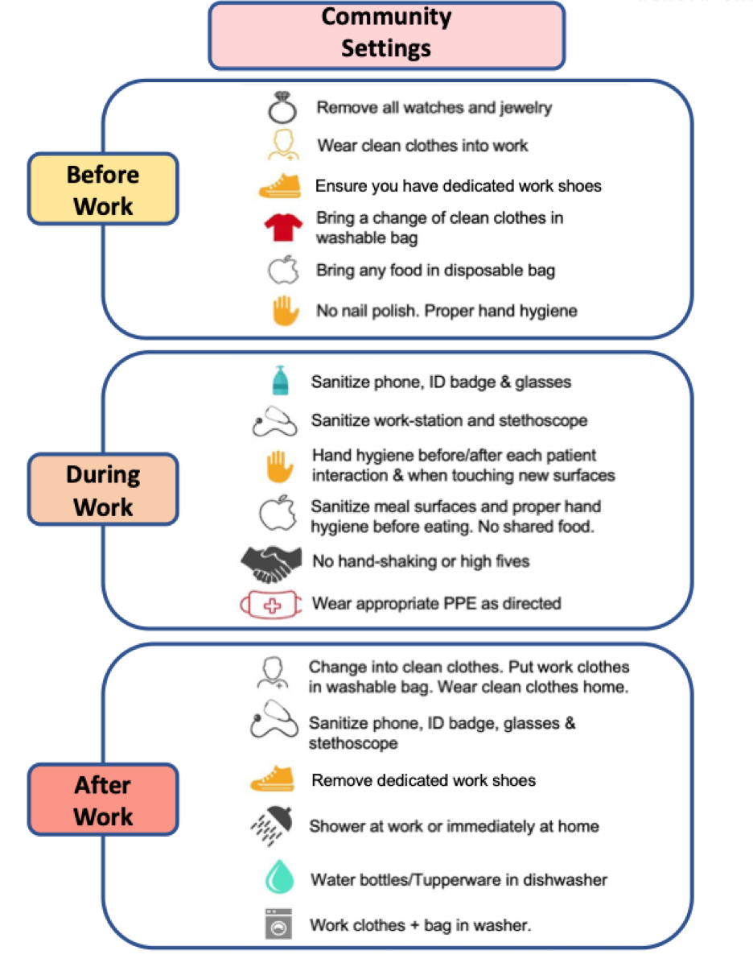

PPE donning and doffing videos (courtesy of Island Health)
- Donning
- Doffing

PPE donning and doffing guides (from Interior Health)
- Optimal Use of PPE (pg. 17)
- Donning (pg. 15)
- Doffing (pg. 16)

Staff tasks prior to opening of the office
- All staff use hand hygiene and don a mask immediately upon entering the clinic. This mask stays on until lunchtime, after which a new mark is donned
- Open disinfected rooms and:
  - If communal stethoscopes are used, use alcohol wipes to clean ear pieces of the disinfected stethoscopes and return to “Clean Stethoscope” baskets in designated room
  - Make sure exam room is set up properly
- Place a sign on the front door and barrier in the waiting room to ensure only scheduled patients are entering the clinic and patients remain the required physical distance to personnel at all times.
- Ask patients to arrive no more than 5 minutes before their appointment. If patients arrive earlier than 5 mins, they need to wait elsewhere (e.g. in their vehicle) until appointment time.
- Create a designated “dirty” work area for team members in case they are unable to complete charting in the exam room (e.g. patient needs to wait 15min after vaccine.)
- Limit the number of exam rooms used as much as possible.
- Ensure that all necessary PPE is easily accessible.
- Ensure that a hand sanitizer and glove station is set up outside exam rooms for easy access.
- Staff should work where they are able to see patients enter the clinic.
  - Most clinics will have a reception desk in which case the suggestion is to install plexiglass shielding for staff and add markings on the floor to ensure the required minimum 2 m distance between patients and staff
- Review daily in-person appointments and put in “prep” notes so that onsite staff can prepare the necessary equipment for the physician when they prep the patient.
  - For example: If there is a newborn/Well Baby Visit appointment:
    - Confirm baby scale is correctly weighing by testing with weight & place baby scale with necessary items into a room before the patient enters room
    - Prep vaccine trays where relevant using the following process:
      - Vaccine tray to be labelled with patient’s FULL NAME and DOB
      - Place into tray:
        - Vaccine vial(s), needles, alcohol swabs, band aids and any needed supplies
        - Checklist outlining what vaccine is in tray
- Physicians will sort out themselves as to who sees which patient. (Ideally, depending on the number of appointments booked, only 1 physician will see all patients to reduce PPE usage and exposure.)

Safety measures to take prior to all appointments
Preventative measures should be taken before contact with patients to minimize risk of transmission
- Call patients before their appointment to
  - screen them for risks—rescheduling if they become sick, are placed on self-isolation or have travelled out of the country within the last 14 days,
  - educate them of changes to office protocols, and
  - that they should attend appointments alone when possible and not bring friends or children.
- Email patients any forms that need to be filled out so clients can complete them before arriving at the clinic. This cuts down on needing pens, etc.
- Office Preparation
  - Post signage at the clinic entrance to assist with communicating expectations (i.e. hand hygiene, (pg. 5,6), physical distancing (pg. 25), respiratory etiquette, (pg. 19), reporting illness or travel history, occupancy limits (pg. 3), and no entry if unwell or in self isolation (pg. 13)
  - Limit exchange of papers during transactions (i.e. receipts), move to contactless payments
  - Use single use items where necessary (i.e. disposable cups)
  - If clinic layout prevents physical distancing, consider alternative approaches (i.e. asking clients not to enter the clinic until receiving a text message)
  - Keep records of all staff training (i.e. training for donning/doffing/use of PPE, training on work safe procedures)
- If possible, check the patient's temperature before their appointment, ideally outside the clinic.
- All patients should be screened for COVID symptoms prior to and upon arrival (patients should be notified of this upon booking their appointment)
  - Patients screening positive should be redirected home for a virtual appointment or referred to a Health Authority assessment clinic or the Emergency Department (depending on severity of symptoms) if physical examination is necessary
  - Patients screening positive should be referred to a testing site (patients can now self-refer)

Clinic workflows for Physicians
The following information is sourced from Rosh and Mehta (2020).
- All individuals seeing patients are to perform hand hygiene and put on a mask as soon as they arrive in the clinic prior to doing anything else. This mask stays on until it is removed for lunch. After lunch, put on a NEW mask.
- Prior to opening of the clinic, review booked patients to see if you need any equipment for prep (baby scale, Chemstrip urine dipstick, etc.) and ask staff to have these items either in the room before the patient arrives or close to the room.
- When you are ready to see your first patient:
- Don PPE (mask should already be on)—gloves and eye protection.
- Assess your patient: take history from as far away as possible and then move to examination (try to spend as little time as possible in close contact).
- When administering vaccines/medications, please do the following:
  - Cross check the vaccine/medication vial(s) against provided checklist (this is a safety measure to reduce risk of medical error)
  - Draw up the vaccine/medication and inject the patient yourself.
- When assessment completed
  - If patient is to leave right away
    - Gloves remain on
    - Ask patient to use hand sanitizer as they leave
    - Complete all charting in the room
    - Remove exam table paper and leave table exposed
    - Still in the room: discard gloves, leave stethoscope and other equipment used OR take to wipe down
    - Keep eye protection and mask on unless soiled
    - Perform Hand Hygiene
  - If patient must remain in room
    - Leave stethoscope and other equipment used in room OR take to wipe down, clear exam table paper
    - Open door for yourself and before leaving room, discard gloves
    - Perform hand hygiene
    - Then either chart at a dedicated workstation (if available) or leave charting until the end of day.
- Between patients:
- Wipe down stethoscope and other equipment that touched patient
- Perform hand hygiene
- Put on gloves before next patient and repeat process above until all patients seen
- Once last patient seen (at end of day or at lunch), complete all steps below:
  - Whether patient remaining in room or leaving, clear exam table paper leaving table exposed.
  - Discard gloves in room
  - Remove stethoscope and eye protection and leave in room.
  - Perform hand hygiene.
  - Leave exam room.
  - Perform hand hygiene.
  - Remove mask and discard.
  - Perform hand hygiene.
- Let staff know the last patient has left

Staff tasks upon closing
The following information is sourced from Rosh and Mehta (2020).
- Discard exam table paper, wipe exam table with a disinfectant wipe, remove gloves and discard in room
- Leave room
- Perform hand hygiene
- Remove goggles and stethoscope and place in “Do Not Use” bin at designated dirty area for later disinfection.
- Perform Hand hygiene
- Remove mask and discard
- Perform Hand hygiene
- Let staff know last patient has left, so that:
  - Staff can lock doors and put up signage notifying of next opening time
  - Staff perform hand hygiene after locking door and placing sign

Pick up and drop off protocol
The following information is sourced from Rosh and Mehta (2020).

NO PICK-UP | NO DROP-OFF
Urine Specimen Bottle  - Patient should go directly to the lab with a requisition to complete tests/drop off samples  Old Medical records  - Email old medical records only (not the whole chart) at no charge and patient can pick up hard copies post-pandemic if still required  - If email consent isn’t given, records can be mailed or picked up post-pandemic  Work clearance forms  - Scan, upload, and email to patient or employer  - Fax to employer  Forms  - Scan and email to patient if possible  - Mail to the patient if privacy concerns with email  Requisitions  - Fax the requisition directly to the lab (LifeLabs has set up a central fax number for any lab)  - Email to patient and ask them to print it somewhere if they don’t have a printer (e.g. a friend)  - Mail it to the patient | ANY SAMPLES FOR LAB PICK-UP  - Patient should go directly to the lab with a requisition to complete tests/drop off samples. Consider labeling the requisition using the BCCDC labelling guidelines, (pg. 26-28), e.g. “HCW 1” for Health Care Workers  Any vaccines or medications to be stored  Old medical records  - Records can be emailed when possible. If not, ask the patient to wait until post-pandemic to drop off records  - Touch-base with Physician to ensure records are not immediately required for the patient’s ongoing care:  - “FYI - patient is only able to drop off a hard copy of medical records. Please advise admin if these records are urgently required for ongoing care. Otherwise, please confirm that the records can be dropped off when the COVID situation has resolved.”  - If only physical copies are available and the Physician has stated that records are required  - Call and ask the previous family MD to fax records if they still have copies. Advise them that the patient was given a hard copy, but due to COVID we are only accepting urgent pick-up/drop-off and want to request a faxed copy instead.  Forms  - Ask patient to scan and email or mail

PICK-UP AVAILABLE | DROP-OFF AVAILABLE
Medications  - B12 vials  - Testosterone vials  - Patient specific vaccines held in fridge  - Allergy injections  - STI medication  Swabs  - Some labs are not accepting self-collected labs  FIT-tests  - Labs are not accepting FIT tests at this time | 3rd Party Deliveries

Step 4: Develop communication plans and training
You must ensure that everyone entering the workplace, including workers from other employers, knows how to keep themselves safe while at your workplace.
- We have a training plan to ensure everyone is trained in workplace policies and procedures.
- All staff and team members have received the policies for staying home when sick.
- We have posted signage at the office, including occupancy limits (pg. 3) and effective hygiene (pg. 5, 6) practices.
- We have posted signage at the main entrance indicating who is restricted from entering the premises, including visitors, staff and team members with symptoms.
- Clinic Leadership have been trained on monitoring staff and team members and the office to ensure policies and procedures are being followed.

Step 5: Monitor your workplace and update your plans as necessary
Things may change as your business operates. If you identify a new area of concern, or if it seems like something isn’t working, take steps to update your policies and procedures. Involve workers in this process.
- We have a plan in place to monitor risks. We make changes to our policies and procedures as necessary.
- Staff and team members know who to go to with health and safety concerns.
- When resolving safety issues, we will involve health and safety committees or other staff and team members

Step 6: Assess and address risks from resuming operations
If your workplace has not been operating for a period of time during the COVID-19 pandemic, you may need to manage risks arising from restarting your business.
- We have a training plan for new staff and team members.
- We have a training plan for staff and team members taking on new roles or responsibilities.
- We have a training plan around changes to our services, such as new equipment, processes, or products.
- We have reviewed the start-up requirements for vehicles, equipment, and machinery that have been out of use. We have identified a safe process for clearing systems and lines of product that have been out of use/expired.

Appendix

Document Name | Organization | Page
Environmental Cleaning and Disinfectants for Clinic Settings | BCCDC | 1-2
Occupancy Limit Sign | WorkSafeBC | 3
Communicate with Patients | Doctors of BC | 4
Hand Hygiene | BCCDC | 5
Wash your hands | WorkSafeBC | 6
Daily Fit for Work or Essential Visitor Screening Questionnaire | Alberta Health Services | 7
Daily Fit for Work Screening during COVID-19 for Community Physicians and Teams | Alberta Health Services | 8-12
Do not enter if you have symptoms sign | WorkSafeBC | 13
Optimal Use of Personal Protective Equipment | Interior Health | 14
Donning PPE | Interior Health | 15
Doffing PPE | Interior Health | 16
How to Wear a Face Mask | BCCDC | 17
Homemade Cloth Face Coverings | Centers for Disease Control and Prevention | 18
Cover coughs and sneezes | WorkSafeBC | 19
OFAA protocols during the COVID-19 pandemic | WorkSafeBC | 20-22
Working from home | WorkSafeBC | 23-24
Physical distancing sign | BCCDC | 25
COVID-19: Testing Guidelines for British Columbia | BCCDC | 26-28
Primary Care Respiratory Assessment Clinic Information and Patient Referral Process | Interior Health and TRDFP | 29
Primary Care Respiratory Assessment Clinic Referral Source Algorithm | Interior Health and TRDFP | 30
Primary Care Respiratory Assessment Clinic Patient Messaging | Interior Health and TRDFP | 31
Community Testing for COVID-19 at UPCC | Interior Health | 32

