PANEL MANAGEMENT Quick Reference

Contents
Before getting started on Empanelment 1
SOS Current (August 2019) Standardized Approach 1
Evaluation tracking tools 1
Attachment Code 97606 in South Okanagan/Simlkameen 1
Duration of visit 2
Type of encounter 2
Empanelment 2
Hypertension 401 2
Diabetes 250 2
Heart Failure 428 3
Anxiety 300 3
Depression 311 3
Dementia/Alzheimer 290, 331 4
Alcohol Dependence 303 4
Drug Dependence 303 4
Chronic Pain 3384 5
COPD 496 5
Chronic Liver Disease 571 5
Frailty V15 6
Osteoarthritis 715 6
Chronic Kidney Disease 585 6
Ischemic Heart Disease 414 7
Cerebrovascular Disease 436 7
Polypharmacy 7
Calculating Panel Size 8
TIPS AND TRICKS TO CONSIDER 8
Using the batching feature 8

Before getting started on Empanelment
1. Explain to the provider and support staff at clinic your role and that you will be booking regular huddles to assist in
- education on panel management
- confirmation on doing for individual patients
- relationship building
2. Time to review the workbook and explain the purpose of the workbook as defined on the GPSC website
3. Enter all “Pre” scores in your workbook (in PDF version on Page 28, or GPSC online version at Phase 2 Step 2) to show significance of clean-up to yourself.
4. Introduce SOS Standardized Approach with the Primary Care Network codes.
5. Make profile templates for future use in coding patients in profile and for provider to easily add coded entry.

SOS Current (August 2019) Standardized Approach
Hypertension (401)
Heart Failure (428)
Osteoarthritis (715)
Anxiety (300)
Depression (311)
Substance Use (Drug Dependence 304, Alcohol Dependence 303)
Dementia/Alzheimer (290, 331)
COPD (496)
Diabetes (250)
Chronic Kidney Disease (585)
Ischemic Heart Disease (414)
Cerebrovascular Disease (436)
Chronic Pain (3384)
Chronic Liver Disease (571)
Frail (V15)
Polypharmacy
Optional: Rheumatoid Arthritis (714), Osteoporosis (733), Asthma (493)

Evaluation tracking tools

Attachment Code 97606 in South Okanagan/Simlkameen
All Clinics need to provide data for attachment. In SOS Division, for new patient attachment, bill 97606 (no fee code) to MSP. (Both the Ministry of Health and the Local Division of Family Practice will collect data to make sure they were fulfilling commitment made through the PCN.)

Duration of visit
By changing the appointment status to reflect different stages of a patient’s duration at the clinic on either or both the day sheet and in visit note within patient chart.

Type of encounter
Encourage providers and MOAs to identify correctly the type of encounter: in office, virtual, phone, email, home, etc.

Empanelment
Active patients in SOS as a standard: any patient that you have seen within the past 5 years with the exception of patients under the age of 18 years whom will remain active. (A provider can decide different standard for active patient if desired)
(To allow the Outcomes dashboard reports to run effectively you can add a visit note to all the patients that will remain active, this will allow the report to show they have been seen within the last 5 years.)
Long term care patients are still active patients (have been billed a long term care code of 000114 or 000115 in the past 3 years).
It is important to educate all the providers and staff: If an inactive patient calls into the clinic the MOA will have to reactivate them.

Hypertension 401
Ask what terminology has been used when adding to profile (example high bp, HTN, hypertensive, HBP) Hint: “white coat” is often a contra indication.
What do you consider hypertension (ex: 140/90 is that high enough?)
Accupril, Amlodipine, Atenolol, Bisoprolol, Cozaar, Diltiazem, Diovan, Enalapril, Furosemide, HCTZ, Hydrochlorothiazide, Hytrin, Lasix, Lisinopril, Lopressor, Losartan, Metoprolol, Norvasc, Perindopril, Prinivil, Ramipril, Triamterene, Valsartan, Vasotec, Zestril
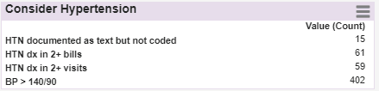
Charts where billing for the annual chronic care incentive (hypertension) 14052 have been used

Diabetes 250
Ask for text in profile. (for example, DM, type 1, Type II, type2, diabet)
Actos, Aspart
, Bydureon, Byetta, Farxiga, Gliclazide
, Glimepiride
, Glipizide, Glucophage
Glyburide
, Humalog, Humilin / NPH
Invokana, Janumet, Januvia, Lantus, Levemir, Liraglutide
, Metformin, Novorapid
, Tradjenta, Victoza
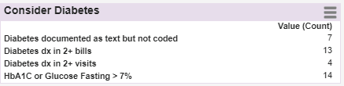
What do you consider Diabetes? (ex. A1C > 7.0 is that high enough?)
Look for incentive billing code 14050 billed.

Heart Failure 428
Ask what terminology may have been used when adding condition to patient profile. (examples HF, CHF, LVF, LVEF, DD, Diastolic dysfunction).
Accupril, Aldactone, Altace, Cardizem, Carvedilol
, Clopidogrel, Coreg, Coumadin
, Digoxin,
Nitrostat, Spironolactone
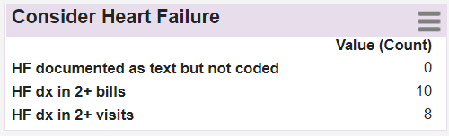
Brain natriuretic peptide (BNP 30934-4) test the protein levels and if are higher than normal you are in heart failure. It also depends on age, so for older people higher numbers are normal.
What do you consider heart failure in BNP levels? (ex. BNP > 100 is that high enough? For which age ranges do you want to go higher?)
Look for the incentive billing code 14051.

Anxiety 300
Many providers have coded the combination, Anxiety/Depression, as 50B. Text in profile. (examples GAD, panic, OCD, neurotic, hysteria, phobic, obsessive-compulsive, neurasthenia, depersonalization syndrome, hypochondria)
Abilify, Ativan, Bupropion, Celexa, Citalopram, Cymbalta, Effexor, Escitalopram, Fluoxetine, Lexapro, Mirtazapine, Paroxetine, Paxil, Pristiq, Prozac, Remeron, Sertraline, Trazodone, Wellbutrin, Xanax, Zoloft
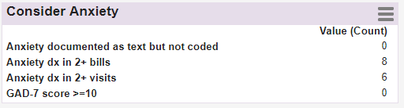
If the provider is using Med Access to reflect GAD 7 scores use the GAD-7 score >=10 report.

Depression 311
Many providers have coded the combination, Anxiety/Depression, as 50B.
Text in profile. (examples MDD, PHQ9, mood, PTSD, manic, depress)
Abilify, Bupropion, Celexa, Citalopram, Cymbalta, Effexor, Escitalopram, Fluoxetine, Lexapro, Mirtazapine, Paroxetine, Paxil, Pristiq, Prozac, Remeron, Sertraline, Trazodone, Wellbutrin, Xanax, Zoloft
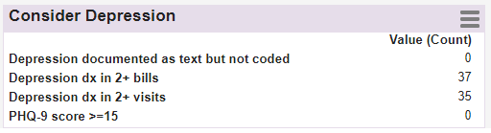
If the provider is using med access to reflect PHQ 9 scores, use the PHQ-9 score >=15 report. At the bottom of PSP template an additional template is listed that requires at least 2 PHQ-9 tests.

Dementia/Alzheimer 290, 331
Text in profile. (examples cognitive impair, cerebral degeneration, pick's disease, senile, hydrocephalus, Jakob-Creutzfeldt, Creutzfeldt, leukoencephalopathy)
Donepezil, Galantamine, Rivastigmine, Memantine (ebixa), Aricept, Exelon, Reminyl
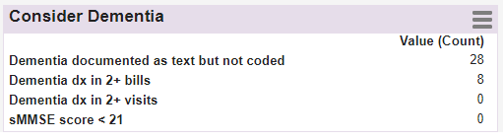
If the provider is using Med Access to reflect MMSE scores, use the sMMSE score < 21 report to identify more patients to confirm diagnosis.

Alcohol Dependence 303
Text in profile. (examples ETOH, alcohol, alcoholic, liver disease, cirrhosis)
Disulfiram (Antabuse), Fluoxetine (Prozac), Acamprosate (campral), Topiramate, Baclofen
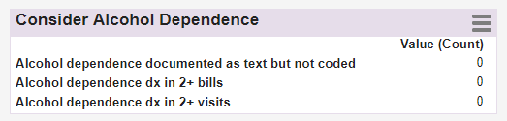

Drug Dependence 303
Text in profile. (examples OAT, Opioid dependence, Dependence, dependent, marijuana, cannabis, cocaine, overdose, morphine, barbiturate, amphetamine, hallucinogens)
Methadone, Methadose, Suboxone, Kadian,
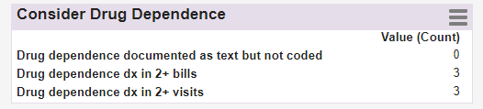

Chronic Pain 3384
Text in profile. (examples opioids, pain lasting 3 months or longer, lower back pain, fibromyalgia)
Tramadol, gabapentin, oxycodone, Vicodin, dilaudid, oxycontin, hydrocodone, Percocet, celebex, naproxen, ketorolac, amitriptyline, Demerol, Tylenol with codeine #3, fentanyl, methadone
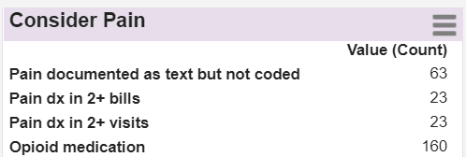
Last way to identify Chronic Pain patients is by working directly with your provider and run report from the Outcomes dashboard.

COPD 496
Text in profile. (examples Bronchi, CPD, pulmonary disease, airway obstruct, airways obstruct, obstructive pulmonary, emphysema, bronchiectasis)
Advair, Breo, Bronchodilators, Ellipta, Flovent, Oxygen, Prednisone, Roflumilast, Seebri, Spiriva, Symbicort, Tudorza, Ventolin, Zithromax
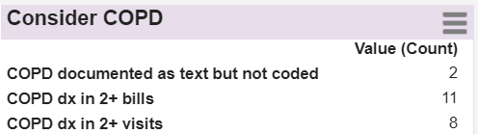
Look for the incentive billing code 14053 billed
Under consults and investigations look for Respirology reports, spirometry and pulmonary function test.

Chronic Liver Disease 571
Text in profile. (examples Liver failure, Cirrhosis, liver disease, Viral hepatitis, Hepatitis C, Hep C, Hepatic encephalopathy, Wilson's disease, Steatohepatitis, biliary cholangitis)
No examples
Creating the report for increased levels in Alanine aminotransferase (ALT or SGPT), Aspartate aminotransferase (AST or SGOT), Gamma glutamyl transferase (GGT), hepatitis C RNA positive test.

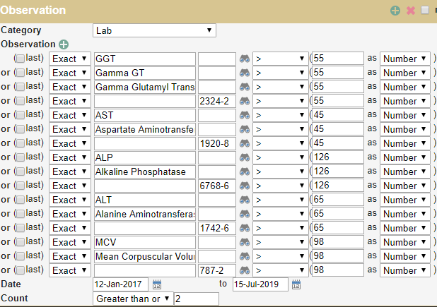

Frailty V15
Text in profile. (examples Long term Care, assisted living, dependent, care giver)
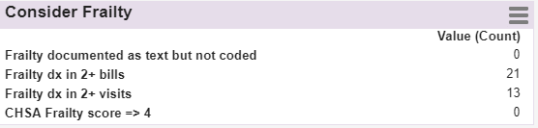
Look for incentive complex care code 14075/V15.
Create a list of patients that are over the age of 85 and have provider look at list to identify Frail patients.

Osteoarthritis 715
Text in profile. (examples OA, psoriasis, psoriatic arthritis, Psoriatic arthropathy)
Celecoxib
, Corticosteroid
, Cymbalta
, Diclofenac
, Diflunisal,
Duloxetine,
Etodolac,
Flurbiprofen
Hyaluronic acid
, Indomethacin,
Ketoprofen
, Ketorolac
, Mefenamic acid
, Meloxicam
, Nabumetone
, Naproxen
, Piroxicam
, Sulindac,
Tiaprofenic acid,
Tolmetin
, Triamcinolone
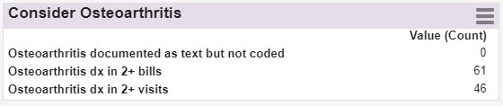
Look at consults and investigations. X-ray reports will comment on osteoarthritis.

Chronic Kidney Disease 585
Text in profile. (examples CKD, CRF, renal impairment, kidney disease, renal failure)
Amlodipine, Atorvastatin, Calcium, Ciclosporin, Dialysis, EPO, Hemodialysis, IV Iron, Lasix, Prednisolone, Ranitidine, Vitamin D
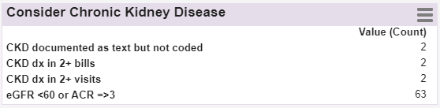
Look at consult reports from nephrology and integrated health centre renal program.

Ischemic Heart Disease 414
Text in profile. (examples IHD, ASHD, CAD, angina, MI, myocardial infarction, stent, nstemi, angina coronary atherosclerosis, aneurysm of heart)
Captopril, Enalapril, Fosinopril, Lisinopril, Perindopril, Quinapril, Ramipril, Trandolapril
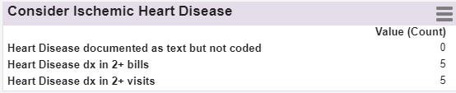
Look at consult reports from nephrology and integrated health centre renal program.

Cerebrovascular Disease 436
Text in profile. (examples ICD, CVD, CVA, stroke, TIA, Lacunar infarct, cerebrovascular, Leukoma, leukaoriosis, leukokeratosis leukoariosus, apoplexy)
No examples
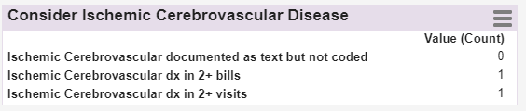
Looking at consult reports including neurology and integrated health centre stroke prevention clinics.

Polypharmacy
When patients are referred the active medication list is always attached. Other providers such s locums need to see an accurate list of medications.
Educate to the provider that Med Access EMR defaults every medication to Continuous if it is not changed to Short Term.
Discontinue meds that have not been renewed for the last 18 or 24 months. Explain to the provider that the entries will not be deleted, they are just going to move lower to the Inactive section of the meds. Ask how old prescriptions should be before you move them.
Ask your provider for any exceptions (examples: aspiring, diabetic strips and vitamins) Ideally, they should be renewed so they do not show as expired.
Start the clean-up by first looking at charts with fewer meds.
If there are only 1, 2 or 3 to remove, click on the red stop-sign icon. If there are more click on the “Discontinue” icon (just under the “Imm” tab)

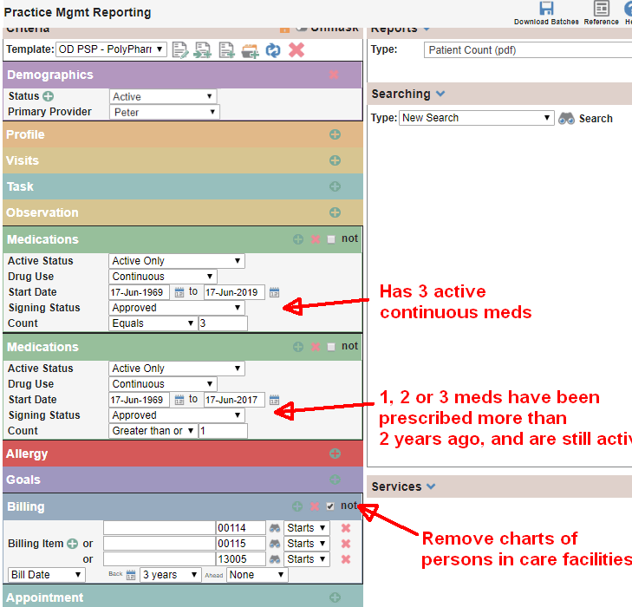

Calculating Panel Size
In a preceding huddle ask the questions you will need to calculate the panel size calculations.
- What days do you normally work in a typical work week? (Ask if full or half days)
- How many weeks of holidays do you take a year?
- Do you have locum coverage for all those weeks?
- How many patients on average do you see in a day?
- If you could describe a month in the past year that would be your typical month which month would it be?

TIPS AND TRICKS TO CONSIDER
When booking your huddles with your provider. Try not to interrupt their workflow by saving your questions under a task that will be saved in your own personal task box (My tasks).
Be clear with your notes so a different person can understand the meaning at a later date.
When building report criteria, note if the selected text should be searched as “Start with”, “Contains” or “Whole word”. Manipulate the criteria within the reports to allow for this.

Using the batching feature
Add a comment/your name/date explaining the reason for the batch action - so that other people would be able to understand why in 5 years of now!
When running reports to find information in profiles, remember Family history will show in reports if you don’t change the search’s “Category” to Medical or Psychiatric or whatever is required.
Look at the sidebar of the chart (you can customize that) for quick access to some data - you may save time by not having to open some tabs.

